

Automated Car-Plate Recognition System (ACRS)

SOI-2021-2120-0019

Date of Submission: 08-Feb-2022

Submitted By:

SOI-2021-0008

|  |  |
| --- | --- |
| 19045346 | SOONG JIA KANG DANIEL |
| 19028935 | MUHAMAD IZHARFAN B ZURAIMI |
| 19047269 | NURUL NATASHA BTE RIZAL |
| 19022315 | ELLY HANIZ BTE MOHAMED GHAZALI |

# ACKNOWLEDGEMENTS

We would like to express our thanks and gratitude to our Supervisor, Ms Shannen Ang for her guidance and support given to us throughout the C300 project despite her busy schedule. We would like to thank each of the team members for the hard work and cooperation in completing the project.

**TABLE OF CONTENTS**

ACKNOWLEDGEMENTS 2

ABSTRACT 4

1 Introduction 6

2 Project Specification and Plan 11

2.1 Project Overview 11

2.2 Functional Requirements 12

2.3 Project Plan 12

3 Business Analysis 15

3.1 Business Issues 15

3.2 Market Analysis 15

3.3 Business Solutions 16

4 System Design and Implementation 17

4.1 System Architecture 17

Detailed System Design 18

*5* System Testing *(Test Case)* 20

6 User and Technical Documentations 39

6.1 User Documentation/Guide/Manual 39

6.2 Technical Documentation (Installation guide/Manual) 65

7 Conclusions 66

References 71

Appendices 75

Project Poster 76

# ABSTRACT

The key objective of the project is to support SGSecure. In the event of a school lock-down, all vehicle access to Republic Polytechnic (RP) will be restricted to RP staff registered vehicles. There will only be a single-point-of-entry into RP and OES will need to verify the existence of the vehicle record before it can enter RP. The total number of vehicles registered with RP is more than 500 and the only means of checking is through manual check. We are recommending an Automated Recognition System (ARS) that is equipped with licence plate recognition capability.

The project is implemented in PythonAnywhere.

Skills required:

* Python
* Python Flask
* HTML
* Javascript
* Jquery
* SQLAlchemy
* API

The project managed to accomplish:

* User Management (CRUD, User Audit)
* Vehicle Management (CRUD, Vehicle Audit)
* Account
* Post (Feedback and Bug)
* 11 Reports including Dashboard, Filtering, Chart
* Vehicle Entry Screening
* Vehicle Tracking Screening
* Appeal Management
* Import External CSV File for Users and Vehicles
* Event Management
* Send Email
* Display data through Ajax table

The project has been successfully completed as of 15 January 2022.

# Introduction

As of now, there is only a single-point-of-entry into RP and OES will need to verify the existence of the vehicles’ record before it can enter RP. There are more than 500 vehicles registered with RP and the only means of checking through the list is by doing a manual check.

This problem would mean that the security guard would have to manually keep track of all the cars and number plates which is impossible to do as there are alot of registered vehicles. By solving this problem, the security of the school will be greatly enhanced as the security guards will be able to keep track of the vehicles entering RP more efficiently.

Major tasks and deliverables of the project are:

* Vehicle Management module to add, edit, delete and perform mass-upload of vehicles and owner information
* AI Image recognition system to screen for licence plate number
* Vehicle matching system to identify owner and status of vehicle clearance

Project Scope Expansion:

* Main Menu implemented alongside with submenus for user-friendly interface
* User Management - contains user profile, create, delete, update and mass upload of user, forget password, change password, login, logout, showing user list by using Ajax table and User Audit where admin are able to track what changes the user makes.
* Report - Admin are able to view a dashboard and 11 charts of different report, view a detailed list and filter the chart based on their choices
* Event Calendar - contains clickable calendar to view event details, create, delete and update event details, showing Event list by using Ajax Table
* Post - Users are able to post feedback and bugs that they noticed when using the web application to allow developers to solve the issues.
  + Feedbacks
  + Bugs
* Appeal Request and Management
* Track Vehicle Function:
  + 30 Minutes Grace Parking - Users can check for the duration of the vehicle when found to be parked illegally. Vehicle will automatically be listed in the Warning List when found to be parked at the illegal location for more than 30 minutes.
  + Warning State - Vehicles exceeding the 30 minutes grace period will automatically be given a warning.
  + Blacklist State - Vehicles will automatically be listed in the blacklist when appearing in the warning list after 5 times.

We solved the problem by creating a mobile friendly web application in PythonAnywhere which allows the security guards to keep track of the vehicles entering RP by scanning their car plate number.

Our solution can be applied daily as the security guards can use our web application whenever a vehicle enters RP. The best condition that makes our web application useful would be when there are events occurring in RP or when there is a school lockdown where only authorised vehicles can enter RP.

The main deliverable points are a mobile web friendly application where it includes different management based on what their roles are:

Public User :

* The public are able to login into the system.
* Public who want to login and forget their password can request to reset their password via “Forget Password”. The token will be sent to the user email for them to reset their password.
* Public is able to view the calendar's dates that shows “Event” highlighted in blue and “Lockdown” highlighted in red and also able to click into a specific event type to view for more information of the event.
* The public are able to submit an appeal if their vehicle is blacklisted from the school. (This will remove their records if the estate officer approves their appeal form).

Security Guard (User) :

* Users are able to view the calendar's dates that shows “Event” highlighted in blue and “Lockdown” highlighted in red and also able to click into a specific event type to view for more information of the event with the vehicle number that entered into the school on that event date.
* Users are able to edit their profile such as their “Username”, “Email”, “Contact” and also be able to change their password.
* Users are able to take a picture of the vehicle to check if the specific vehicle number is authenticated into the school. Alternatively they can also manually key in the vehicle number instead of using a camera if their phone camera is not working. This will check against the vehicle list to see which vehicle is authenticated into the school during lockdown.
* Users are able to view the list of vehicles coming into the school by “Today” or choosing a specific lockdown date to see the cars that have come in for vehicle audit purposes.
* Users are able to take a picture of the vehicle to track if the specific vehicle number is illegally parked into the school. Alternatively they can also manually key in the vehicle number instead of using a camera if their phone camera is not working. This will track how long the vehicle number has parked into the school.
  + If the vehicle has parked more than 30 minutes it will be considered breaking the parking rules and the vehicle number will be placed into the warning list.
  + If the vehicle number has exceeded 5 offences by parking illegally in school, it will be placed into the blacklist.
  + Users are able to view the 30 minutes grace parking list, warning vehicle list and blacklisted vehicle list.
* Users are able to view and create either a Bug related post or a Feedback related Post.
  + Once created any users can comment or like their own posts or other users' posts.
  + Users are also able to view what has the specific user post or they can also choose to view a specific type of post example : Viewing all Bug Posts and Viewing all Feedback Posts.

Estate Officer (Admin) :

* Admin is able to view the calendar's dates that shows “Event” highlighted in blue and “Lockdown” highlighted in red and also able to click into a specific event type to view for more information of the event with the vehicle number that entered into the school on that event date.
* Admin is able to view, create, update and delete each event details under the Event List.
* Admin is able to view, create, update and delete each user account in the User Management. Admin can also import the CSV into the database which consists of a list of Users.
* Admin can update their profile like for their username, email and contact. They can also change their password.
* Admin can view the User Audit where it will show the action and the amendments by each user with the date and time indicated.
* Admin can take a picture of the vehicle to check if the specific vehicle number is authenticated into the school. Alternatively they can also manually key in the vehicle number instead of using a camera if their phone camera is not working. This will check against the vehicle list to see which vehicle is authenticated into the school during lockdown.
* Admin can view the list of vehicles coming into the school by “Today” or choosing a specific lockdown date to see the cars that have come in for vehicle audit purposes.
* Admin are able to take a picture of the vehicle to track if the specific vehicle number is illegally parked into the school. Alternatively they can also manually key in the vehicle number instead of using a camera if their phone camera is not working. This will track how long the vehicle number has parked into the school.
  + Admin can view a list of information about cars that were inserted in the the 30 Minutes Grace Parking List after being caught parking illegally for more than 30 minutes. They can also delete the car plate from the list if the vehicle is no longer found to be parked at the illegal location for less than 30 minutes.
  + If the vehicle is caught to be parked for more than 30 minutes, the car plate number will automatically be transferred to the Warning List where Admin can view the car plate number and the accumulated number of offences made. They also have the authority to delete the car plate from the warning list.
  + If the vehicle has exceeded 5 offences by parking illegally in school, it will be placed into the blacklist where Admin can both view and delete.
  + Admin are able to view the appeal list where the publicans submit and are able to choose to “Approve” or “Reject” the appeal request. Once Approved, it will send an email to notify the vehicle user that their request is approved and their vehicle number will be removed from the blacklist section.
* Admin are able to view, create, update and delete each vehicle in the Vehicle Management. Admin can also import the CSV into the database which consists of a list of vehicles. Admin can choose to reset the whole vehicle list or add to the list of vehicles.
* Admin are able to view and create either a Bug related post or a Feedback related Post.
  + Once created any users can comment or like their own posts or other users' posts.
  + Admin can also view what has the specific user post or they can also choose to view a specific type of post example: Viewing all Bug Posts and Viewing all Feedback Posts.
* Admin can also view multiple charts of each report in a dashboard. For each report, they can view the data in a table, chart and have a detailed view of the list for that particular report. In the detailed list, admin can filter and search. Admin can filter the report by clicking on the checkbox for them to select the report they want to view. For each chart, admin can also click on the legend for them to choose the data they want to view in the chart.

# Project Specification and Plan

## Project Overview

Our motivation for this project was to help our OES’ to be more efficient in their jobs and make it easier for them by developing a mobile friendly web application that identifies the licence plate number from an image taken from a mobile phone that will match against the list of approved vehicles for entry access.

To develop a mobile friendly web application using Flask Python to identify the licence plate number of a vehicle using a mobile phone, that will match against the list of approved vehicles.

Project Scope:

* User Management
* User Audit
* Report
* Calendar Function
* Entry Vehicle Screening
* Vehicle Tracking Function
  + 30 Minutes Grace Parking
  + Warning State
  + Blacklist State
  + Appeal
* Post (Feedback/Bug)
* Vehicle Management

The assumptions of this project is that we will have a mobile friendly web application that is able to operate well on both mobile and computer. The web application will be able to scan car plates which will be checked against the vehicle list that is in the database that will be allowed in school during lockdown.

## Functional Requirements

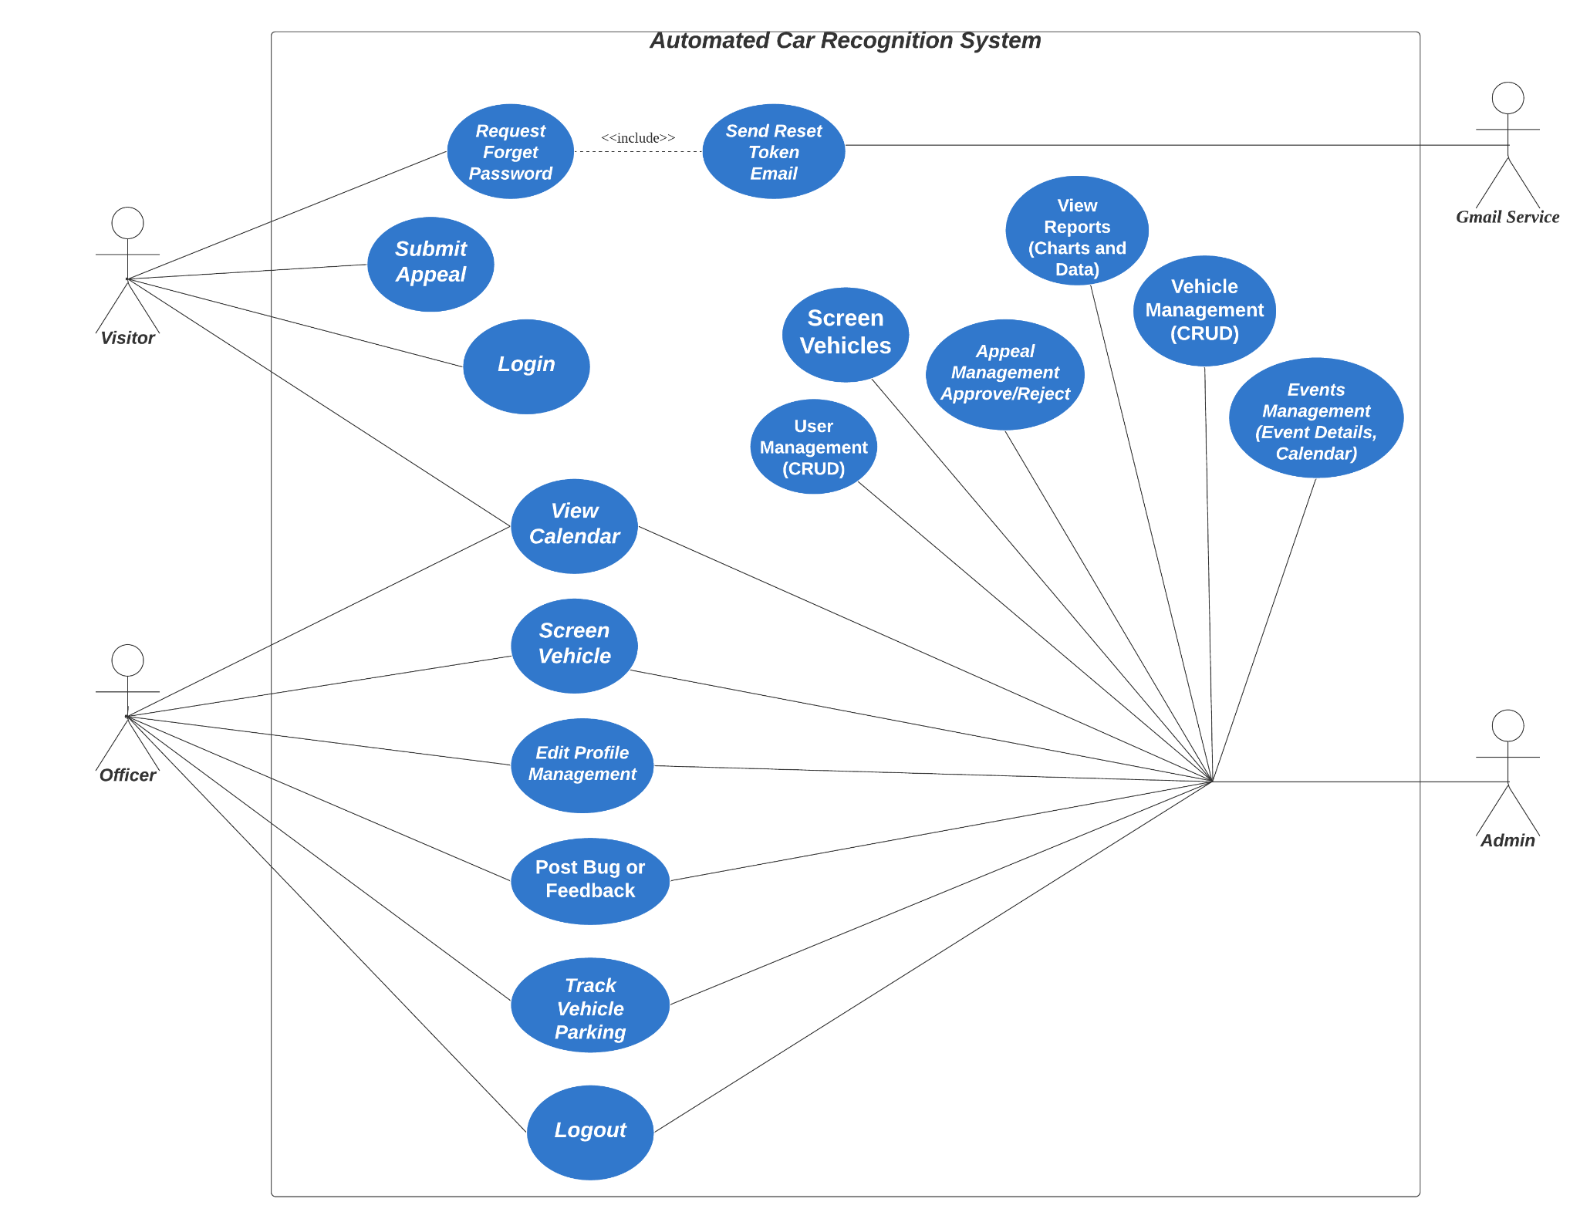

## Project Plan



Task Allocation and Progress:

* Soong Jia Kang Daniel

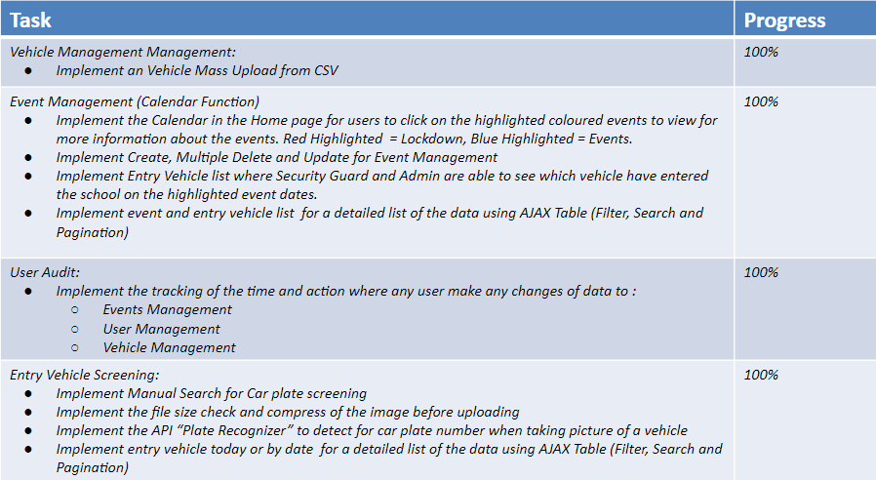

* Nurul Natasha Bte Rizal

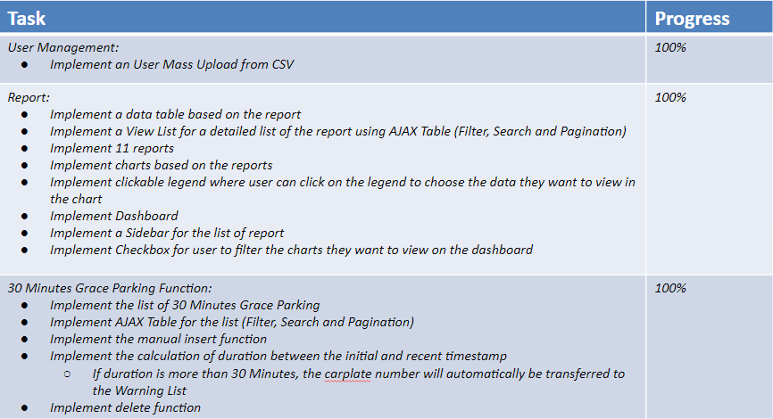

* Muhamad Izharfan Bin Zuraimi

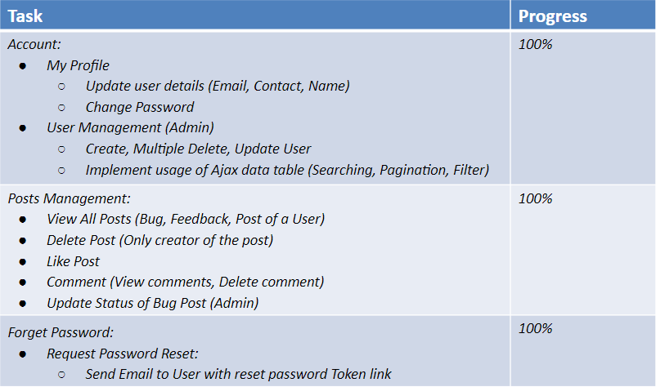

* Elly Haniz Bte Mohamed Ghazali

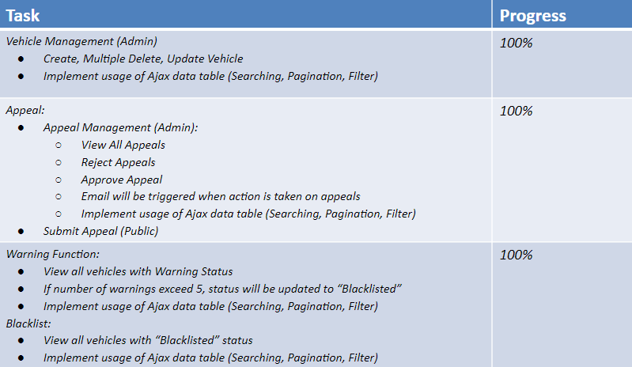

# Business Analysis

## Business Issues

RP has an exercise to support SGSecure where the school will go into lockdown. However, this is currently being done manually by the Estate Officers. With our mobile friendly web application, this exercise will be less burdensome for the Estate Officers as they would be able to keep track of the vehicles entering RP by scanning their car plate numbers in our mobile friendly web application.

## Market Analysis

There are many different API for car plate recognizer, by developing this project we have to choose 1 of the API to implement. Most of the API usually needs to pay which is why we have also decided to research how to implement it without an API.

API that we have researched (Includes non-API):

* OpenALPR
  + This is a car plate recogniser API. In order to use this API, we need to choose a plan and pay the amount of $29 for 2500 maximum calls per month to use it. Even though it might be a quality API to use, there are similar API’s that we don’t have to pay for to use the API.
  + <https://cloud.openalpr.com/sign-up/#steps-uid-0-h-2>
* OpenCSV (Non API)
  + We have tried to implement the car plate recogniser without the API and have installed many different python libraries such as, “OpenCSV”, “TensorFlow”, and “EasyOCR” to start implementing the codes which takes up most of the storage space in PythonAnywhere.
  + It is also very inconvenient to implement many steps of codes to make the whole process of scanning a car plate to work and with the time constraint, we decided to look for an API.
* Plate Recogniser API (Chosen API)
  + This is the current API we are using for our development. The reason why we chose this API is because it is free with 2500 maximum calls per month. It is also very easy to implement and doesn't need a bunch of code to make it work and they provide clear documentation on the process of implementing the API.
  + It also supports many car plate types depending on the country.
  + <https://app.platerecognizer.com/accounts/plan/>

Our mobile friendly web application is targeted for companies that require security lockdowns which would require them to keep track of the vehicles entering their vacinities. However, our mobile friendly web application also includes useful APIs such as our Car Plate Scanner which can be implemented into other applications.

## Business Solutions

This project is to help our Security Guards in doing their work. Any vehicle is able to enter RP. Cars are only allowed to park in designated areas such as car parks. There are times in which cars are illegally parked on the school compound. A warning is usually given for the first 5 offences, after which the vehicle will be blacklisted and may be subjected to fines or wheel clamping.

Under normal circumstances, the Security Guards would have to go around and manually check each vehicle number against a list. This method took too much time and was not efficient. Human error could also cause the information keyed in to be inaccurate.

Having an IT solution to this problem eliminates human error as most of the work is being done by the system. They simply had to capture the car plate number and the system would do the rest. It also helps to make the whole process more efficient.

This solution has also helped our RP Estate Officers. As admins, they are able to:

* Approve / Reject Appeals
* View List of Blacklisted, Warning and Registered Vehicles
* View Reports
* Manage Users
* Manage Vehicles, etc.

The RP Estate Officers are able to do more tasks efficiently and the overall workload is lessened.

# System Design and Implementation

When we first set up our web application on PythonAnywhere, there was no software needed to be installed in order for us to run the application.

PythonAnywhere is a website that allows us to set up our web application virtually. It allows us to implement all our codes on a website where each of us do not have to make any commits into GitHub or to retrieve any project files that might take up any of our hardware memory.

In the event that any of our laptops malfunction during the project period, we do not have to worry about our project files being lost as PythonAnywhere is a cloud based website that allows us to store all our files and run our application.

We paid for the monthly subscription of PythonAnywhere to expand our cloud storage and to have the authority to use external APIs.

The hardware needed for this project would be a mobile phone with a camera to scan car plates for the vehicle number.

## System Architecture

In regards to our system architecture, we used PythonAnywhere which does not require any installation for any third party software as it is a web based application to set up our Flask web application.

PythonAnywhere offers us a cloud-based MySQL database where we are able to store all our data by creating our own database structure. Instead of manually creating said structure, we used SQLAlchemy codes to create the database table on its own when we run the web app. We also used SQLAlchemy to execute various SQL commands and logic in the system.

The API we used for our system is known as “Plate Recognizer”. We implemented the codes by having the API key and certain documents to allow our system to detect the car plate. It will allow our users to take a picture and activate the API to detect the plate number.

Our mobile friendly web application is created on PythonAnywhere which can be accessed through a mobile phone or a computer virtually. Through a mobile phone, users are able to use the web application to scan plate numbers of vehicles that are trying to enter RP which we achieved by using an API called “Plate Recognizer”. The scanned plate number will then be checked against the list of approved vehicle numbers which has been created in the database PythonAnywhere. We also use SQLAlchemy to check if the scanned vehicle is in the list of approved vehicles in the database.

## Detailed System Design

**Entity Relationship Diagram:**

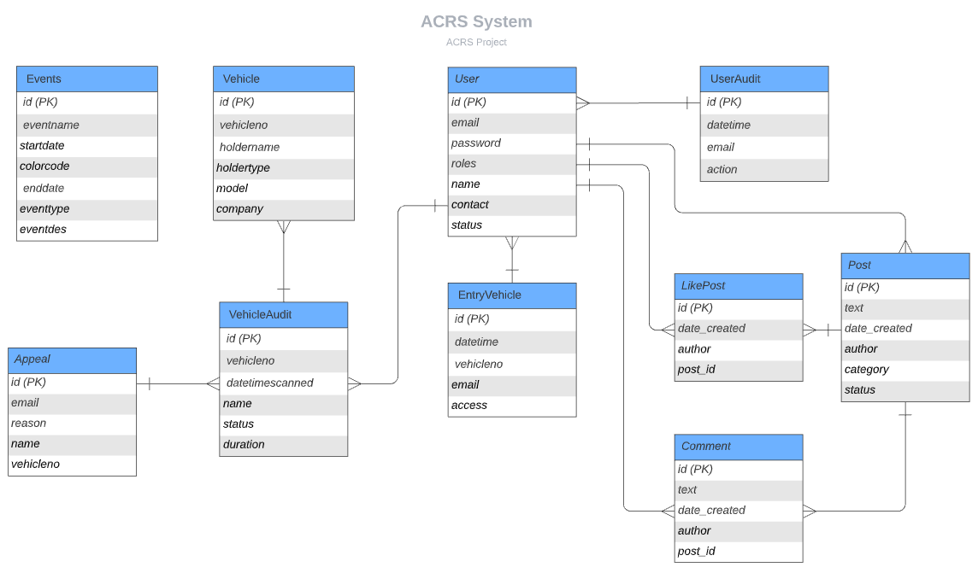

**Page Flow Diagram:**

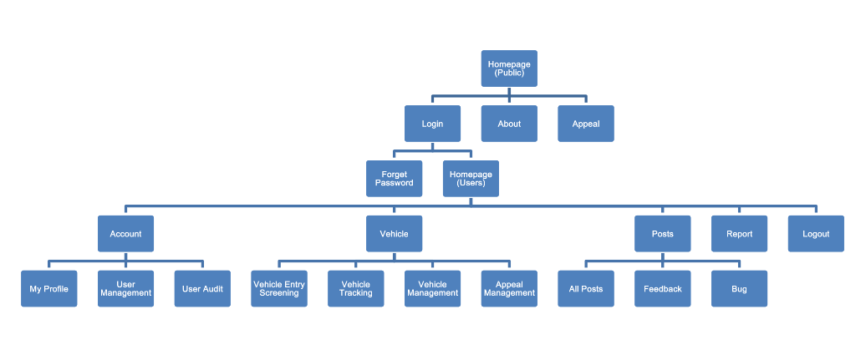

**Use Case Diagram:**



# System Testing *(Test Case)*



The system will be tested via cross check with the Test Case document which we have attached below:

|  |  |  |  |  |
| --- | --- | --- | --- | --- |
| **Test Specification ID :** SOI-2021-2120-0019  **Name of Tester :** Daniel, Elly, Izharfan, Natasha  **Use Case ID :** 0010  **Date of Test :** 29 January 2022  **Description of Test :** Testing the Automated Car Recognition System Web App | | | | |
| **S/No** | **Test Case** | **Expected Result** | **Pass/ Fail** | **Remarks** |
| **ACRS Home (Public users)** | | | | |
|  | Test to see if the public users are able to access the home page of ACRS which will display the menu bar and calendar with all the events types. | * + Public users are able to view the menu bar, calendars with event types. | Pass |  |
|  | Test to see if the public users are able to click on the Blue highlighted event which will bring the user to a new tab and display “Event Title”, “Event Date and Time” and “Event Description”. | * + Public users are able to click the blue highlighted event and display “Event Title”, “Event Date and Time” and “Event Description” on a new tab. | Pass |  |
|  | Test to see if the public users are able to click on the Red highlighted event which will bring the user to a new tab and display “Lockdown Title”, “Lockdown Date and Time” and “Lockdown Description”. | * + Public users are able to click the red highlighted event and display “Lockdown Title”, “Lockdown Date and Time” and “Lockdown Description” on a new tab. | Pass |  |
| **About Page (Public Users)** | | | | |
|  | Test to see if users are able to see the about page by clicking on the “ABOUT” button in the sub-menu. | * Users should be able to view the contents of the about page. | Pass |  |
| **Login / Logout** | | | | |
|  | Test to see if authorized users are able to login into the ACRS webpage and able to see the menu bar and calendar with the events | * + Authorized users are able to view the menu bar and calendar with the events | Pass |  |
|  | Test to see if unauthorized users are not able to login into the ACRS webpage and a message will pop up at the top indicating that the “Email does not exist.” | * + Unauthorized users will view a message at the top indicating that the “Email does not exist.” | Pass |  |
|  | Test to see if users are able to click on the eye icon for them to unhide the password | * + Users are able to click on the eye icon for them to unhide the password | Pass |  |
|  | Test to see if authorised users are able to click on the “Forgot Password?” link which will bring them to a page requesting for their email to reset password | * + Authorised users are able to click on the “Forgot Password?” link and view a page requesting for their email to reset password | Pass |  |
| **Appeal (Public Users)** | | | | |
|  | Test to see if the user is able to click on “APPEAL” in the submenu for public users to submit their appeals for their vehicles | * + Appeal Page is shown to the public users where users have to fill in their “Vehicle Number”, “Holder Name”, “Email” and “Reason”. | Pass |  |
|  | Test to see if there will be an error message shown if the “Vehicle Number” , “Holder Name”, “Email” and “Reason” field is empty | * + When the user does not fill in the fields, an error message will prompt the user to “Please fill out this field” | Pass |  |
|  | Test to see if the public user did not enter a proper email in the “Email” field. | * + Prompt the public users to enter the correct email with the message “Please include an ‘@’ in the email address” | Pass |  |
|  | Test to see if after a public user fills in their details and their vehicle is not in the black list, the message will show “Vehicle Number does not exist in blacklist!” | * + After public users fill in the fields, click on “Send Appeal” and their vehicle number is not in the blacklist, it will display “Vehicle Number does not exist in blacklist!” | Pass |  |
|  | Test to see if after a public user fills in their details and their vehicle is not in the black list, the message will show “Vehicle Number does not exist in blacklist!” | * + After public users fill in the fields, click on “Send Appeal” and their vehicle number is not in the blacklist, it will display “Vehicle Number does not exist in blacklist!” | Pass |  |
|  | Test to see if after a public user fill in their details and their vehicle is in the black list, the message will show “Appeal submitted! It will take 2-3 days for the officer to get back to you through email!” | * + After public users fill in the fields, click on “Send Appeal” and their vehicle number is in the blacklist, it will display “Appeal submitted! It will take 2-3 days for the officer to get back to you through email!” | Pass |  |
| **ACRS Home (User - Security Guard / Admin - Estate Officer)** | | | | |
|  | Test to see if the users are able to access the home page of ACRS which will display the menu bar and calendar with all the events types. | * Users are able to view menu bar, calendars with event types. | Pass |  |
|  | Test to see if the users are able to click on the Blue highlighted event which will bring the user to a new tab and display “Event Title”, “Event Date and Time” and “Event Description”. | * + Users are able to click the blue highlighted event and display “Event Title”, “Event Date and Time” and “Event Description” on a new tab. | Pass |  |
|  | Test to see if the users are able to click on the Red highlighted event which will bring the user to a new tab and display “Lockdown Title”, “Lockdown Date and Time” and “Lockdown Description”. | * + Users are able to click the red highlighted event and display “Lockdown Title”, “Lockdown Date and Time” and “Lockdown Description” on a new tab. | Pass |  |
|  | Test to see if users are able to see the list of entry vehicles coming in on that event date after clicking on the highlighted events on the calendar page. | * + Users are able to see the list of vehicles coming into the school on that event period along with the event details after clicking on the highlighted event. | Pass |  |
| **ACRS Home (Admin - Estate Officer)** | | | | |
|  | Test to see if the users are able to click on “Add Event” and “Event List” button | * + Admins are able to only see the buttons and click them | Pass |  |
|  | Test to see if the users are able to enter the “Event title”, “Start date” , “End date”, “Event type” and “Description” after clicking the “Add Event” button. | * + Admins are able to fill in the fields and add the events | Pass |  |
|  | Test to see if there will be an error message shown if the user submit leaving all the fields empty | * + When user did not fill in the fields the error message will prompt “Please fill out this field” | Pass |  |
|  | Test to see if the user selects the “Event Type” as Event and click the “Submit” button where the calendar will show the event color highlighted in blue on the date admin created. | * + After admin fill out the fields and select “Event” as the event type and click the submit button, display the event highlighted in blue in the home page. | Pass |  |
|  | Test to see if the user selects the “Event Type” as Lockdown and clicks the “Submit” button where the calendar will show the event color highlighted in red on the date admin created. | * + After admin fill out the fields and select “Lockdown” as the event type and click the submit button, display the event highlighted in red in the home page. | Pass |  |
|  | Test to see if the user is able to see the list of events and able to “Filter”, “Search”, “Paging”, “Edit”, “Delete” the event and change the number of entries to be shown. | * Admin can see the list of events and is able to edit, delete, search, filter, paging and change the number of entries to be shown in the list. | Pass |  |
|  | Test to see if the user is able to click the “Edit” button on one of the data and check if all the details of the current data is there for the user to update. | * Once the admin clicks on the “Edit” button on specific data, there is a pop out board showing the current details of the data for the admin to edit. | Pass |  |
|  | Test to see if the user is able to make any changes to the data after clicking the “Update” button | * Once the user makes changes to its event name and clicks on the “update” button it will make changes to the data. | Pass |  |
|  | Test to see if the user are able to make multiple delete by checking which data they don’t want it to be in their list and click “Delete All Selected” | * Once the admin checks on 3 data that they don’t want and clicks on “Delete All Selected” the 3 data will be deleted. | Pass |  |
| **Vehicle Management ( Admin - Estate Officer)** | | | | |
|  | Test to see if non-admins are able to view the vehicle management page. | * + Non-admins will not be able to view the vehicle management page. | Pass |  |
|  | Test to see if users(security guards) are able to view the vehicle management page. | * Users should be able to view the vehicle management page. | Pass |  |
|  | Test to see if users are able to view the vehicle list table on the vehicle management page. | * Users should be able to view the table. | Pass |  |
|  | Test to see if users are able to filter through the vehicle list. | * Users should be able to filter through the list by ascending order once clicked | Pass |  |
|  | Test to see if users are able to sort list by ascending and descending order | * Users should be able to sort the list by ascending and descending order. | Pass |  |
|  | Test to see if admins are able to import the vehicle lists from excel using the “Import Vehicle from CSV” button. | * Users should be able to import CSV files containing the vehicle list. | Pass |  |
|  | Test to see if the user are able to import other file type other than csv when importing the vehicle list | * Users should not be able to choose other file type other than CSV file | Pass |  |
|  | Test to see if the user is able to import csv files with less than 5 columns. | * Users who imported less than 5 columns of csv file will prompt an error “Vehicle CSV file need to be 5 columns” | Pass |  |
|  | Test to see if the user is able to import a csv file that is not readable. | * Users who imported less than 5 columns of csv file will prompt an error “Could not read CSV file please try again” | Pass |  |
|  | Test to see if the user are able to import CSV with 5 rows while clicking on the radio button “Reset Database” and click on import button | * Once the user chooses to click on the “Reset Database” radio button and insert a csv file, it will then successfully remove the current vehicle list in vehicle management and replace it with the ones imported in CSV. | Pass |  |
|  | Test to see if users are able to click on the “Edit” button and view a pop-up page which shows all details of the user with an “Update” button at the bottom. | * Users should be able to edit Vehicle Number, Holder Name, Holder Type, Car Model and Company by editing and clicking the “Update Button”. A pop up message should show “Vehicle Updated Successfully” | Pass |  |
|  | Test to see if users are able add new vehicles using the “Add New Vehicle” button. | * Users should be able to add a new vehicle by entering Vehicle Number, Holder Name, Holder Type, Car Model and Company Name and pressing the “Create Vehicle” button. New vehicles will be added to the list. | Pass |  |
|  | Test to see if users are able to change the number of entries shown on each page. | * Users should be able to change the number of entries shown on a page by using the dropdown list to show either 10, 25, 50 or 100 entries. | Pass |  |
| 33. | Test to see if users are able to navigate through the pages of entry results using the “Previous”, “Next” or number buttons below the table. | * Users should be able to cycle through the pages of entries. | Pass |  |
| **My Profile (User - Security Guard, & Admin - Estate Officer)** | | | | |
|  | Test to see if the user is able to click on “MY PROFILE” in the sub menu and view the user's username, email and contact number. | * + Account page will be shown, showing the user's username, email and contact number. | Pass |  |
|  | Test to see if the user is able to update the user's username, email and contact number by clicking on the “Update” button after editing the details. | * + User’s details will be updated to what the user edited it to be. | Pass |  |
|  | Test to see if the user is able to click on the “Change Password”. | * + Checkpassword page will be shown. | Pass |  |
|  | Test to see if the user is able to go to the Changepassword page by entering their current password and clicking on the “Check Password” button. | * + Changepassword page will be shown. | Pass |  |
|  | Test to see if user is able to change password by entering the new password in the “New Password” field, confirm the new password by entering the new password in the “Confirm Password” field, and clicking on the “Change Password” button | * + User’s password will be updated and the Account page will be shown with a green pop-up message stating, “Your password has been updated!” | Pass |  |
| **User Management (Admin - Estate Officer)** | | | | |
|  | Test to see if admins are able to click on “User Management” under the sub-menu and view a page showing the list of users | * + Admin are able to click on the “User Management” and view a page consist of the list of users | Pass |  |
|  | Test to see if admins are able to filter the user list ascending and descending | * + Admin are able to filter the user list ascending and descending | Pass |  |
|  | Test to see if admins are able to click on the “Edit” button and view a pop-up page which shows all details of the user with an “Update” button at the bottom | * + Admin are able to click on the “Edit” button and view a pop-up page which shows all details of the user with an “Update” button at the bottom | Pass |  |
|  | Test to see if admins are able to delete multiple users by checking on the checkbox and clicking on the “Delete All Selected” button | * + Admin are able to delete multiple users by clicking on the checkbox and clicking on the “Delete All Selected” button | Pass |  |
|  | Test to see if admins are able to search user based on the keyword | * + Admin are able to search used based on the keyword | Pass |  |
|  | Test to see if admins are able to click on the “Create User” button and view a page where details such as “Email”, “Password”, “Roles”, “Full Name”, “Contact Number” and “Status” needs to be filled up | * + Admin are able to click on the “Create User” button and view a page where details such as “Email”, “Password”, “Roles”, “Full Name”, “Contact Number” and “Status” needs to be filled up | Pass |  |
|  | Test to see if admins are able to change and choose the number of entries for the user list | * + Admin are able to change and choose the number of entries for the user list | Pass |  |
|  | Test to see if admins are able to change the page by clicking on the “Previous”, “Next” or the number page | * + Admin are able to change the page by clicking on the “Previous”, “Next” or the number page | Pass |  |
|  | Test to see if admins are able to import user from csv and view in the user list | * + Admin are able to import user from csv and view in the user list | Pass |  |
|  | Test to see if admins are able to import other file type other than csv when importing the user list | * + Admin should not be able to choose other file type other than CSV file | Pass |  |
|  | Test to see if admins are able to import csv files with less than 5 columns. | * + Admin who imported less than 5 columns of csv file will prompt an error “User CSV file need to be 5 columns” | Pass |  |
|  | Test to see if admins are able to import a csv file that is not readable. | * + Admin who imported less than 5 columns of csv file will prompt an error “Could not read CSV file please try again” | Pass |  |
| **Posts (User - Security Guard, & Admin - Estate Officer)** | | | | |
|  | Test if the user is able to click on “ALL POSTS” in the sub menu and go to the Posts page. | * + Posts page will be shown, showing all the Posts created ordered from newest to oldest. | Pass |  |
|  | Test if the user is able to click on “FEEDBACK” in the sub menu and go to the Feedback Post page. | * + Feedback Posts page will be shown, showing all the Feedback Posts created ordered from newest to oldest. | Pass |  |
|  | Test if the user is able to click on “BUG” in the sub menu and go to the Bug Post page. | * + Bug Posts page will be shown, showing all the Bug Posts created ordered from newest to oldest. | Pass |  |
|  | Test if the user is able to click on the “Create a Post” button and go to Make a Post page. | * + Make a Post page will be shown, showing a drop down list that has two options, “Bug” and “Feedback”, followed by an empty text box. | Pass |  |
|  | Test if the user is able to select between the two options, “Bug” and “Feedback” in the drop down list. | * + Once the user has selected between the two options, the drop down list will close, displaying the option that the user has chosen. | Pass |  |
|  | Test if the user is able to type in the text box. | * + Tapping on the tap box will bring up the user’s keyboard which enables the user to key in their feedback/bug. | Pass |  |
|  | Test if the user is able to click on the “Back” button to go back to the Post page. | * + Tapping on the “Back” button will bring the user back to the Post page. | Pass |  |
|  | Test if the user is able to click on the “Post” button to post the feedback/bug. | * + Tapping on the “Post” button will bring the user to the Post page with a message stating, “Post created!”, and with the created post at the top. | Pass |  |
|  | Test if the user is able to click on the like button (Thumbs up). | * + Tapping on the like button will change the button’s colour from white to black and increase the number beside it. Tapping on the button again will “unlike” the post. | Pass |  |
|  | Test if the user is able to comment on the post by typing on the text box that says, “Comment something!”, and clicking on the “Comment” button. | * + Tapping on the “Comment” button will post the comment that the user has entered and increase the number of comments on the post. | Pass |  |
|  | Test if the user is able to click on “View n Comments” to view the comments on the post. | * + Tapping on “View n Comments” will open the comments section showcasing all the comments on the post. | Pass |  |
|  | Test if the user is able to delete their own comments and comments in their posts by clicking on the “Delete” button beside the comment. | * + Tapping on the “Delete” button beside the comment will show a popup to confirm the deletion. Clicking on the “OK” button will delete the comment and decrease the comment count on the post. | Pass |  |
|  | Test if the user is able to delete their own post by clicking on the “Delete” button on their post. | * + Tapping on the “Delete” button on the post will show a pop up to confirm the deletion. Clicking on the “OK” button will delete the post. | Pass |  |
|  | Test if the admin is able to update the status of the bug posts by selecting an option from the drop down list, “New”, “Ongoing”, “Fixed”, and by clicking on the “Update Status” button. | * + Tapping on the “Update Status” button after selecting an option from the drop down list will update the status of the bug post to the status selected and a message stating, “Status Updated Successfully” will be shown. | Pass |  |
|  | Test if the user is able to click on a name to view all posts by the user. | * + Tapping on a name will bring the user to a page that shows all posts created by the user. | Pass |  |
|  | Test if the user is able to click on “Feedback” on the post to view all Feedback posts. | * + Tapping on “Feedback” will bring the user to a page that shows all Feedback posts. | Pass |  |
|  | Tets if the user is able to click on “Bug” on the post to view all Bug posts. | * + Tapping on “Bug” will bring the user to a page that shows all Bug posts. | Pass |  |
| **User Audit(Admin - Estate Officer)** | | | | |
|  | Test if admin are able to view the a list of action done by each user which includes the date, time and email | * + Admin are able to view a list of action done by each user which includes the date, time and email | Pass |  |
|  | Test that the actions is track in the User Audit list when admin import, update, create or delete | * + Actions is tracked in the User Audit list when admin import, update, create or delete | Pass |  |
| **Vehicle Entry Screening (User - Security Guard, & Admin - Estate Officer)** | | | | |
|  | Test if user are able to click on the “Take An Image” button to choose either choose an image file or launch a camera to take a picture | * + User and Admin are able to choose to either upload a file or take a picture by launching the camera | Pass |  |
|  | Test if the system are able to check if the picture the user upload is a valid car plate if it is a valid car plate then it will read the car plate number and check if the car plate is authenticated  If car plate is valid prompt message : “SML4288T APPROVED”  Else it will prompt : “SML4288T IS NOT ALLOWED IN RP” | * + User and Admin took a picture of a valid car plate and the system are able to scan the car plate to see if the car plate is authenticated. | Pass |  |
|  | Test if the system is able to check if the picture is not valid, example. if a random picture is taken eg. walls, living objects. It will prompt the user “Could not find plate number please retake again”. | * + User and Admin will take a picture of a cat and check if the image is valid. Prompt the user “Could not find plate number please retake again” | Pass |  |
|  | Test to see if the user leave the Manual Car plate Search field Empty and click “Search” | * + User and admin will receive a error message asking the user “Please fill out this field” | Pass |  |
|  | Test to see if the user have fill in less than 5 characters in the Manual Carplate search field and click “Search” | * + User and admin will receive an error message asking the user “Please lengthen this text to 5 characters or more (you are currently using 3 characters).” | Pass |  |
|  | Test if the user are able to fill in the Manual Carplate Search and click on the “Search” button where it will check:  If car plate is valid prompt message : “SML4288T APPROVED”  Else it will prompt : “SML4288T IS NOT ALLOWED IN RP” | * + User and Admin fill in the manual car plate search field and check if the car is allowed or not allowed in RP | Pass |  |
| **Vehicle Tracking - Track Vehicles Function (User - Security Guard, & Admin - Estate Officer)** | | | | |
|  | Test if user and admin are able to click on the “Submit” button to upload a picture of the car plate taken using camera | * + User and Admin are able to click on the “Submit” button to upload a picture of the car plate taken using camera | Pass |  |
|  | Test if user and admin can view the car plate number in the 30 Minutes Grace Parking List when successfully uploaded a picture taken using camera | * + User and Admin are able to view the car plate number in the 30 Minutes Grace Parking List when successfully uploaded a picture taken using camera | Pass |  |
|  | Test if user and admin are able to click on the “Insert” button when manually inserting the car plate number | * + User and Admin are able to click on the “Insert” button when manually inserting the car plate number | Pass |  |
|  | Test if an error message will be shown if user and admin click on the “Insert” button when the Manual Carplate Insert field is empty | * + User and Admin will receive an error message stating “Please fill out this field” | Pass |  |
|  | Test if an error message will be shown when user and admin fill in less than 5 characters in the Manual Carplate Insert field and click the “Insert” button | * + User and Admin will receive an error message stating “Please lengthen this text to 5 characters or more (you are currently using 3 characters).” | Pass |  |
|  | Test if user and admin can view the car plate number in the 30 Minutes Grace Parking List when successfully inserting the car plate number manually | * + User and Admin are able to view the car plate number in the 30 Minutes Grace Parking List when successfully inserting the car plate number manually | Pass |  |
| **Vehicle Tracking - 30 Minutes Grace Parking List Function (User - Security Guard, & Admin - Estate Officer)** | | | | |
|  | Test if user and admin are able to view the 30 Mins Grace Parking list consist of “Security Guard Name”, “Carplate Number”, “Initial Track DateTime”, “Recent Track DateTime” and a “Delete” button under the action column | * + User and Admin are able to view the 30 Mins Grace Parking list which consist of “Security Guard Name”, “Carplate Number”, “Initial Track DateTime”, “Recent Track DateTime” and a “Delete” button under the action column | Pass |  |
|  | Test that when scanning the vehicle number for the first time, the column “Security Guard Name”, “Carplate Number” and “Initial Track DateTime” will be filled up | * + Column “Security Guard Name”, “Carplate Number” and “Initial Track DateTime” will be filled up when scanning the car plate number for the first time | Pass |  |
|  | Test that when scanning the vehicle number subsequently, the column “Recent Track DateTime” will be filled up | * + Column “Recent Track DateTime” will be filled up when scanning the car plate number for the subsequent times | Pass |  |
|  | Test if the car plate number is automatically transferred to the Warning List when the calculated duration between the “Initial Track DateTime” and “Recent Track DateTime” is more than 30 minutes | * + Car plate number is automatically transferred to the Warning List when the calculated duration between the “Initial Track DateTime” and “Recent Track DateTime” is more than 30 minutes | Pass |  |
|  | Test if user and admin can click on the “Delete” button to remove the car plate number when the calculated duration between the “Initial Track DateTime” and “Recent Track DateTime” is less than 30 minutes | * + User and Admin can click on the “Delete” button to remove the car plate number when the calculated duration between the “Initial Track DateTime” and “Recent Track DateTime” is less than 30 minutes | Pass |  |
|  | Test if user and admin are able to filter the list accordingly | * + User and Admin can click on the filter at the header to filter the list accordingly | Pass |  |
|  | Test if user and admin are able to search based on the keyword | * + User and Admin can search through the list based on the keyword | Pass |  |
|  | Test if user and admin are able to change the number of entries shown in a list | * + User and Admin can change the number of entries shown in a list | Pass |  |
|  | Test if user and admin are able to change the page by clicking on the “Previous”, “Next” or the number page | * + User and Admin can change the page by clicking on the “Previous”, “Next” or the number page | Pass |  |
| **Vehicle Tracking - Warning List Function (User - Security Guard, & Admin - Estate Officer)** | | | | |
|  | Test if admin are able to view the Warning list consist of “Security Guard Name”, “Carplate Number”, “Number of Offences”, and a “Delete” button under the action column | * + Admin can view the Warning list consist of “Security Guard Name”, “Carplate Number”, “Number of Offences”, and a “Delete” button under the action column | Pass |  |
|  | Test if user are able to view the Warning list consist of “Security Guard Name”, “Carplate Number”, “Number of Offences” | * + User can view the Warning list consist of “Security Guard Name”, “Carplate Number”, “Number of Offences” | Pass |  |
|  | Test if the Number of Offences will be added up by 1 when the same car plate number was transferred from the 30 Mins Grace Parking List | * + Number of Offences will be add up by 1 when the same car plate number was transferred from the 30 Mins Grace Parking List | Pass |  |
|  | Test if the car plate number is automatically transferred to the Blacklist when the Number of Offences reached the maximum of 5 | * + Car plate number is automatically transferred to the Blacklist when the Number of Offences reached the maximum of 5 | Pass |  |
|  | Test if admin can click on the “Delete” button to remove the car plate number in the Warning List | * + Admin can click on the “Delete” button to remove the car plate number in the Warning List | Pass |  |
|  | Test if user and admin are able to filter the list accordingly | * + User and Admin can click on the filter at the header to filter the list accordingly | Pass |  |
|  | Test if user and admin are able to search based on the keyword | * + User and Admin can search through the list based on the keyword | Pass |  |
|  | Test if user and admin are able to change the number of entries shown in a list | * + User and Admin can change the number of entries shown in a list | Pass |  |
|  | Test if user and admin are able to change the page by clicking on the “Previous”, “Next” or the number page | * + User and Admin can change the page by clicking on the “Previous”, “Next” or the number page | Pass |  |
| **Vehicle Tracking - Blacklist Function (User - Security Guard, & Admin - Estate Officer)** | | | | |
|  | Test if admin are able to view the Blacklist consist of “Security Guard Name”, “Carplate Number”, “Number of Offences”, and a “Delete” button under the action column | * + Admin can view the Blacklist consist of “Security Guard Name”, “Carplate Number”, “Number of Offences”, and a “Delete” button under the action column | Pass |  |
|  | Test if user are able to view the Blacklist consist of “Security Guard Name”, “Carplate Number”, “Number of Offences” | * + User can view the Blacklist consist of “Security Guard Name”, “Carplate Number”, “Number of Offences” | Pass |  |
|  | Test if admin can click on the “Delete” button to remove the car plate number in the Blacklist | * Admin can click on the “Delete” button to remove the car plate number in the Blacklist | Pass |  |
|  | Test if user and admin are able to filter the list accordingly | * + User and Admin can click on the filter at the header to filter the list accordingly | Pass |  |
|  | Test if user and admin are able to search based on the keyword | * + User and Admin can search through the list based on the keyword | Pass |  |
|  | Test if user and admin are able to change the number of entries shown in a list | * + User and Admin can change the number of entries shown in a list | Pass |  |
|  | Test if user and admin are able to change the page by clicking on the “Previous”, “Next” or the number page | * + User and Admin can change the page by clicking on the “Previous”, “Next” or the number page | Pass |  |
| **Vehicle Tracking - Appeal List Function (Admin - Estate Officer)** | | | | |
|  | Test if admin are able to view the Appeal List consist of “Vehicle Num”, “Name”, “Email”, “Reason” including a “Approve” and “Reject” button under the status column | * + Admin can view the Appeal List consist of “Vehicle Num”, “Name”, “Email”, “Reason” including a “Approve” and “Reject” button under the status column | Pass |  |
|  | Test if admin are able to filter the list accordingly | * + Admin can click on the filter at the header to filter the list accordingly | Pass |  |
|  | Test if admin are able to search based on the keyword | * + Admin can search through the list based on the keyword | Pass |  |
|  | Test if admin are able to change the number of entries shown in a list | * + Admin can change the number of entries shown in a list | Pass |  |
|  | Test if admin are able to change the page by clicking on the “Previous”, “Next” or the number page | * + Admin can change the page by clicking on the “Previous”, “Next” or the number page | Pass |  |
| **Report (Admin - Estate Officer)** | | | | |
|  | Test if admin are able to view the report overview in a dashboard which consist of various charts based on the different reports | * + Admin can view the report overview in a dashboard which consist of various charts based on the different reports | Pass |  |
|  | Test if admin are able to click on the “Filter Report” button which open the sidebar consist of all the reports for them to choose the report they wanted to view | * + Admin can click on the “Filter Report” button which open the sidebar consist of all the reports for them to choose the report they wanted to view | Pass |  |
|  | Test if the chart is shown on the dashboard when admin check the checkbox of the reports they want to view | * + Admin can check the checkbox of the reports they want to view and the chart will be shown on the dashboard | Pass |  |
|  | Test if the chart will be removed from the dashboard when admin uncheck the checkbox of the report | * + Chart will be removed from the dashboard when admin uncheck the checkbox of the report | Pass |  |
|  | Test if the admin are able to click on “X” button to close the sidebar | * + Admin can click on “X” button to close the sidebar | Pass |  |
|  | Test if the admin are able to click on the side button which will show a list of 11 reports they can click on to view | * + Admin can click on the side button which will show a list of report they can click on to view | Pass |  |
|  | Test if admin are able to view the report which consist of a chart and a data table when clicking on the report name | * + Admin can view the report which consist of a chart and a data table when clicking on the report name | Pass |  |
|  | Test if admin are able to filter the data in the datatable accordingly | * + Admin can filter the data in the datatable accordingly | Pass |  |
|  | Test if admin are able to click on the “View List” link under the action column which shows a page of a detailed list | * + Admin can click on the “View List” link under the action column which shows a page of a detailed list | Pass |  |
|  | Test if admin are able to filter the list and search based on the keyword in the View List page | * + Admin can filter the list and search based on the keyword in the View List page | Pass |  |
|  | Test if admin are able to click on the “Back” button to return to the previous page | * + Admin can click on the “Back” button to return to the previous page | Pass |  |
|  | Test if admin are able to click on the legend to hide or unhide the data they want to view in a chart | * + Admin can click on the legend to hide or unhide the data they want to view in a chart | Pass |  |

*Other Resources for reference on Software Debugging and Testing:*

[*https://en.wikipedia.org/wiki/Software_testing*](https://en.wikipedia.org/wiki/Software_testing)

[*https://braydie.gitbooks.io/how-to-be-a-programmer/content/*](https://braydie.gitbooks.io/how-to-be-a-programmer/content/)

[*http://www.extremeprogramming.org/rules/unittests.html*](http://www.extremeprogramming.org/rules/unittests.html)

# User and Technical Documentations

## User Documentation/Guide/Manual



Public Users:

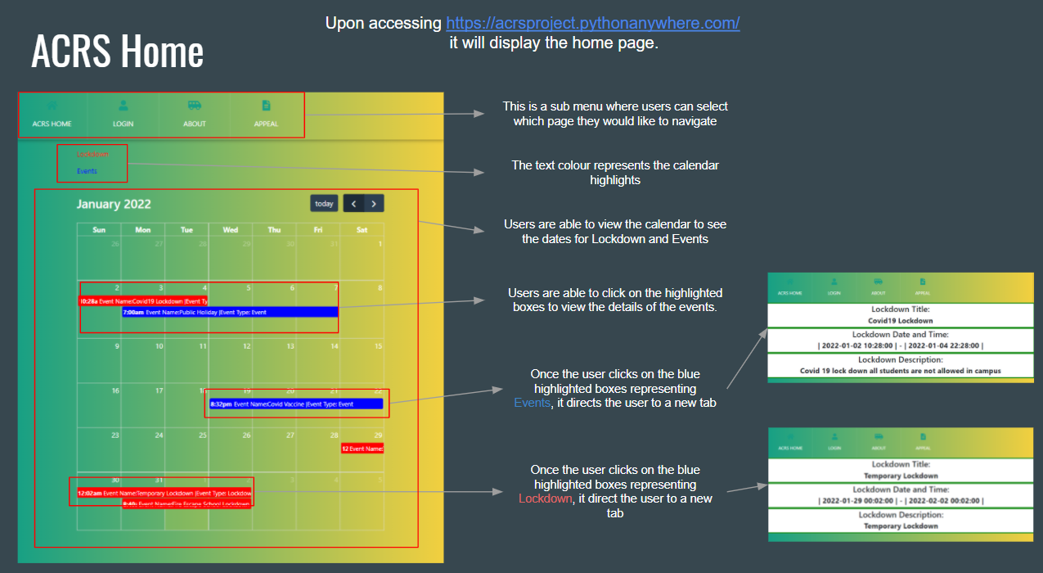

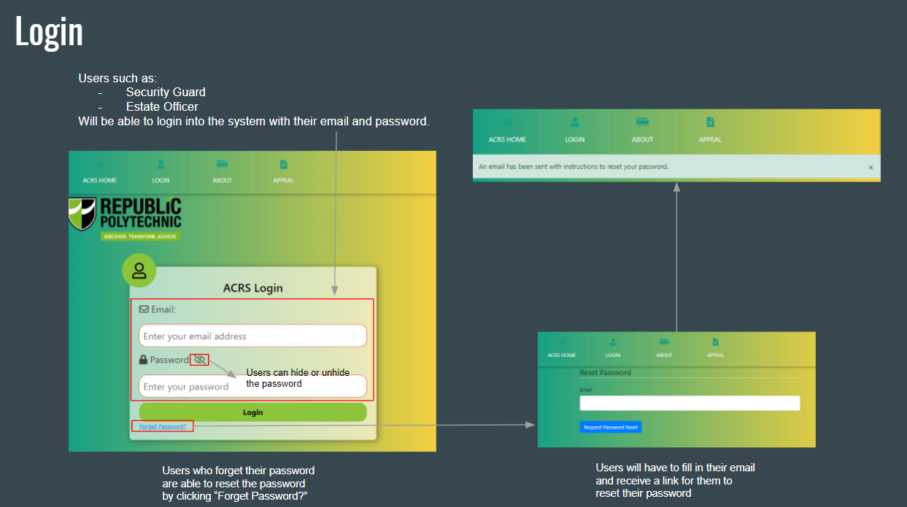

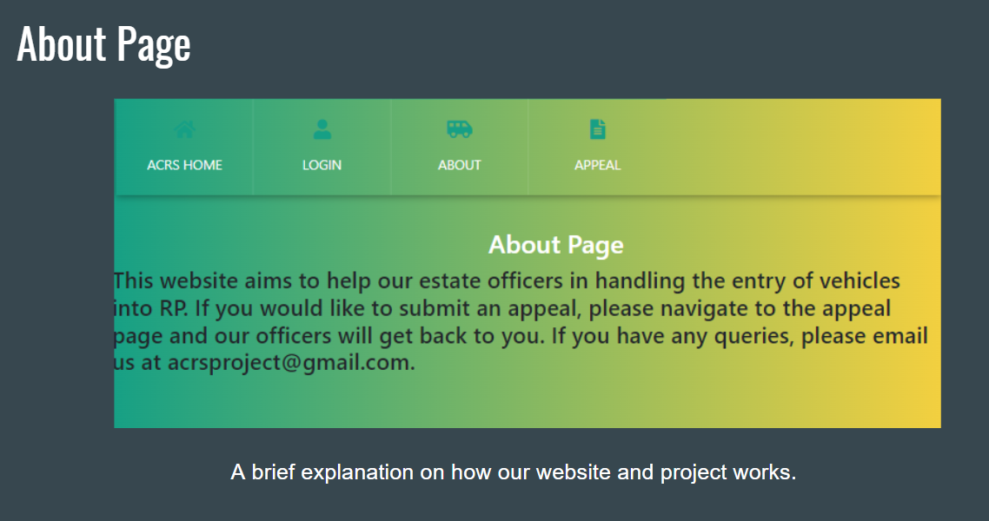

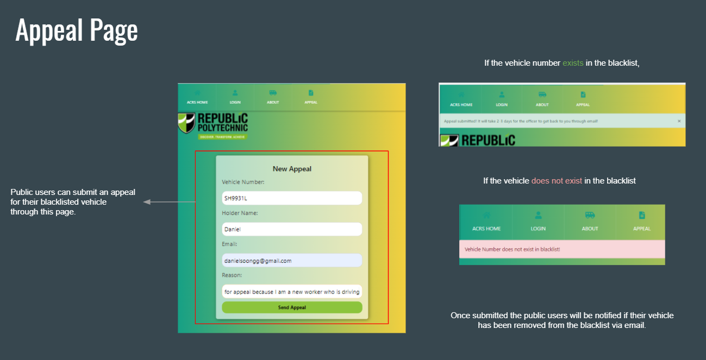

User (Security Guard)

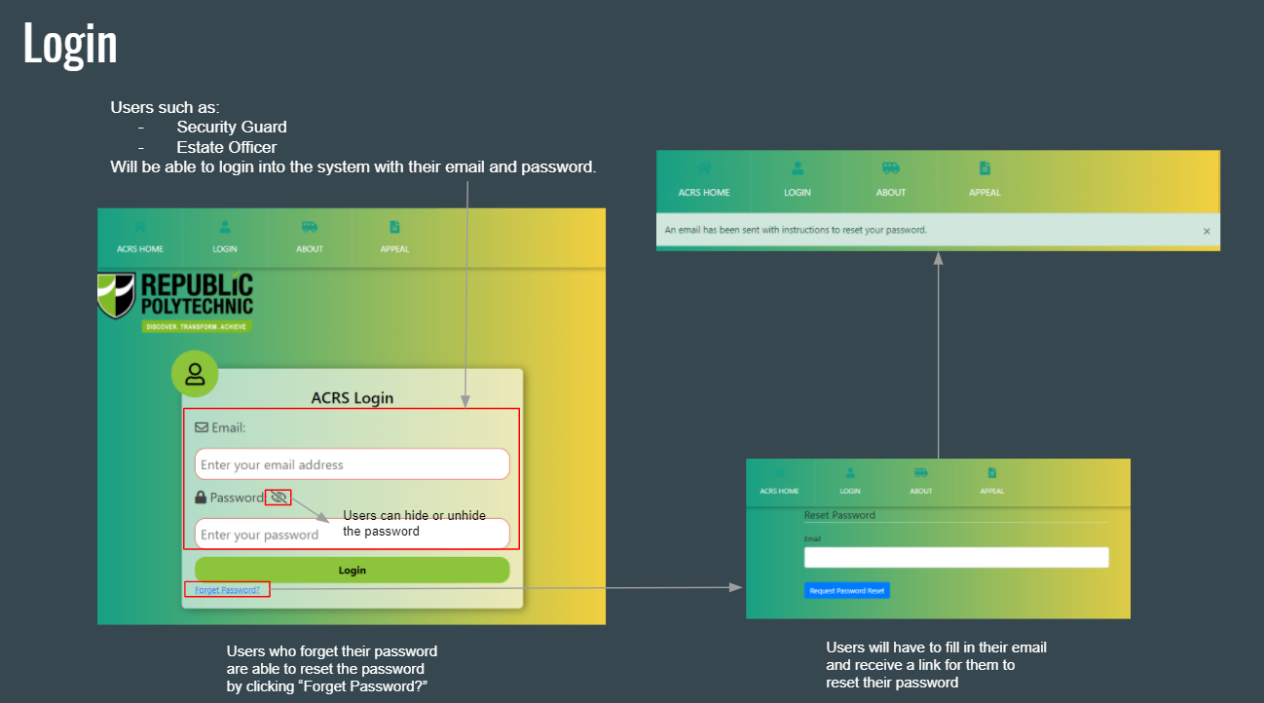

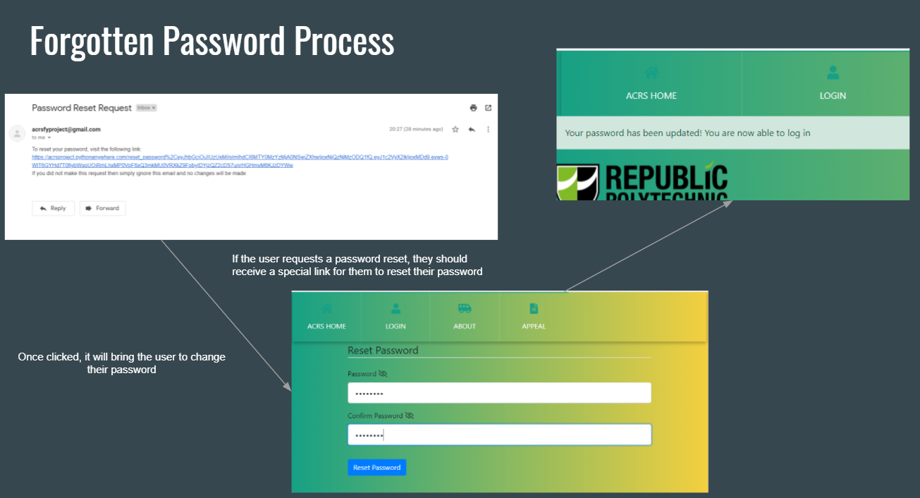

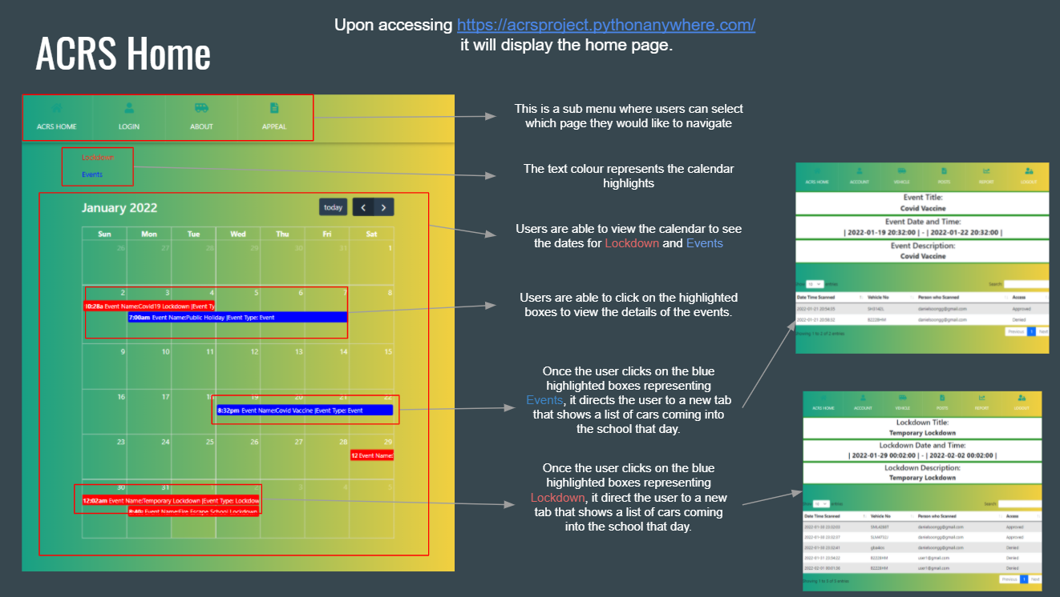

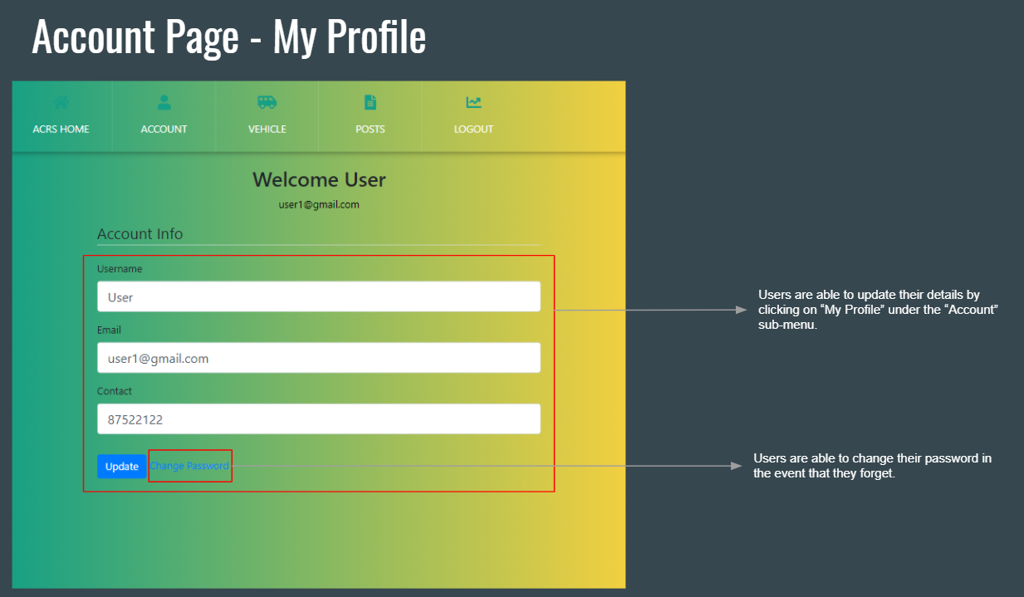

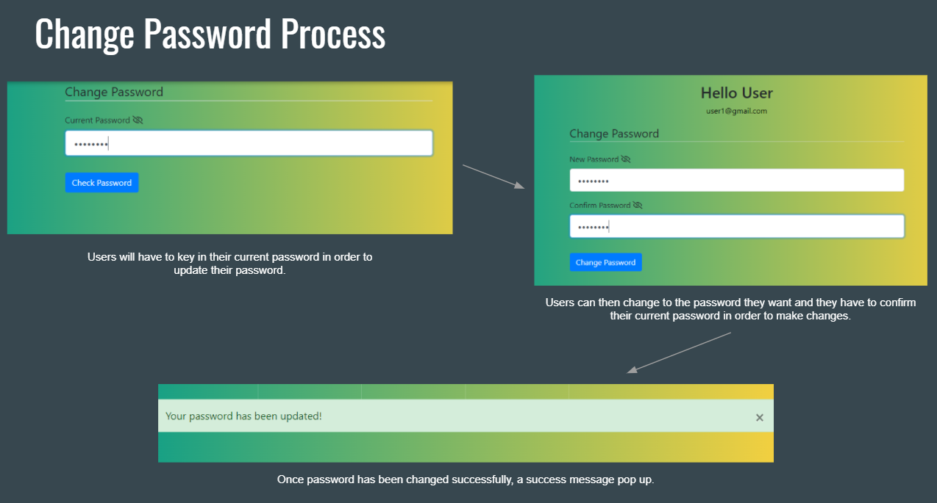

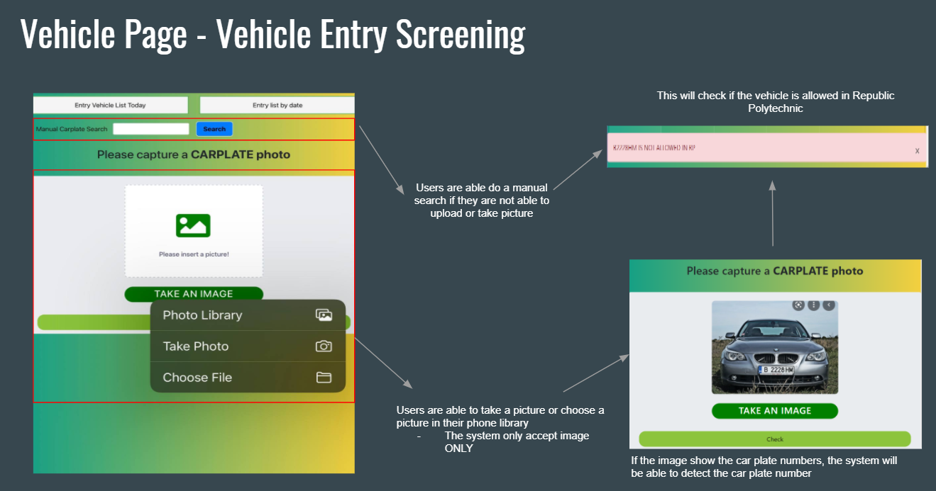

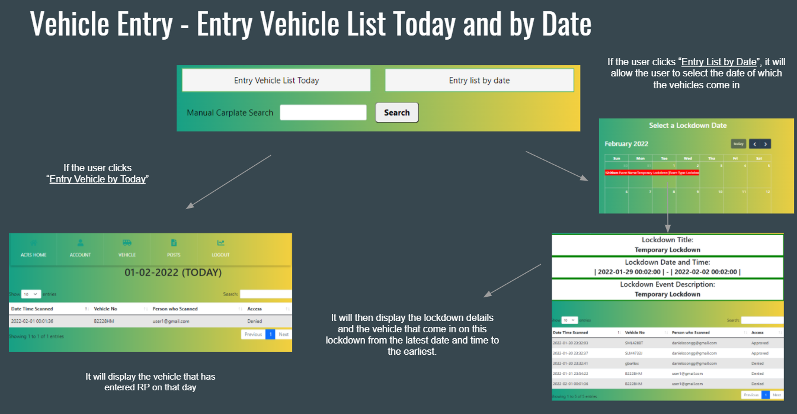

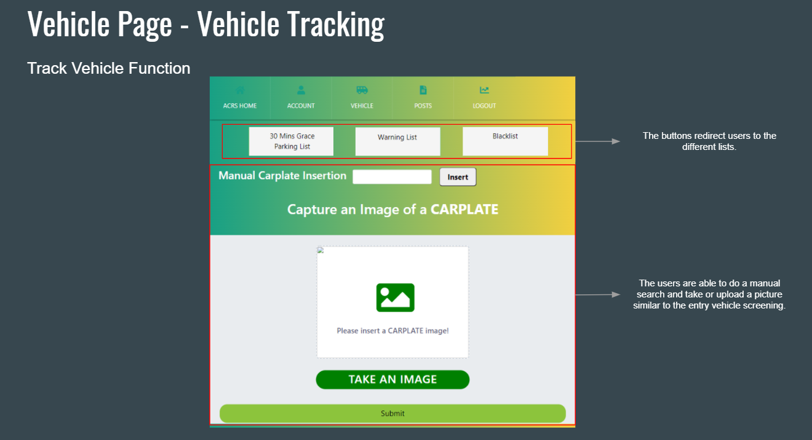

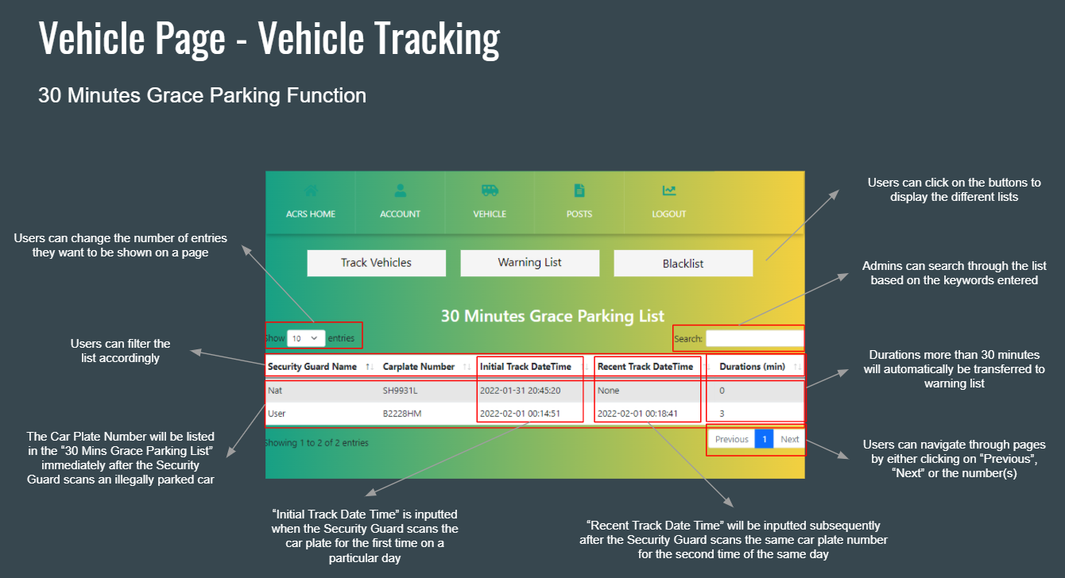

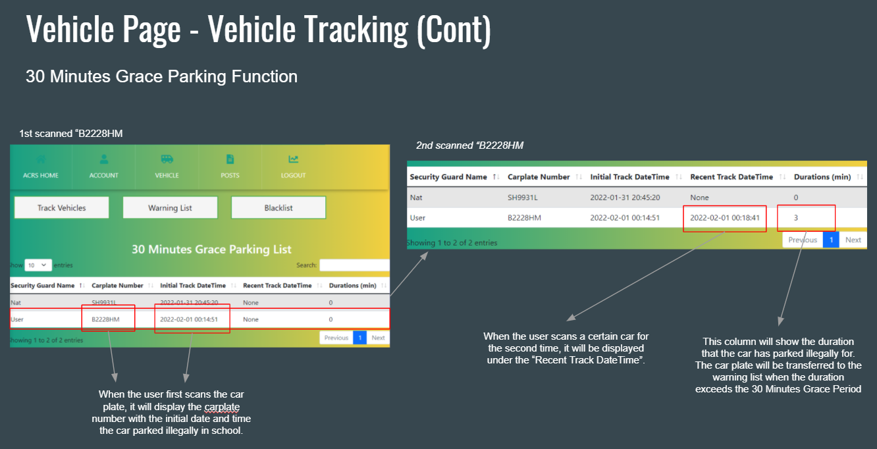

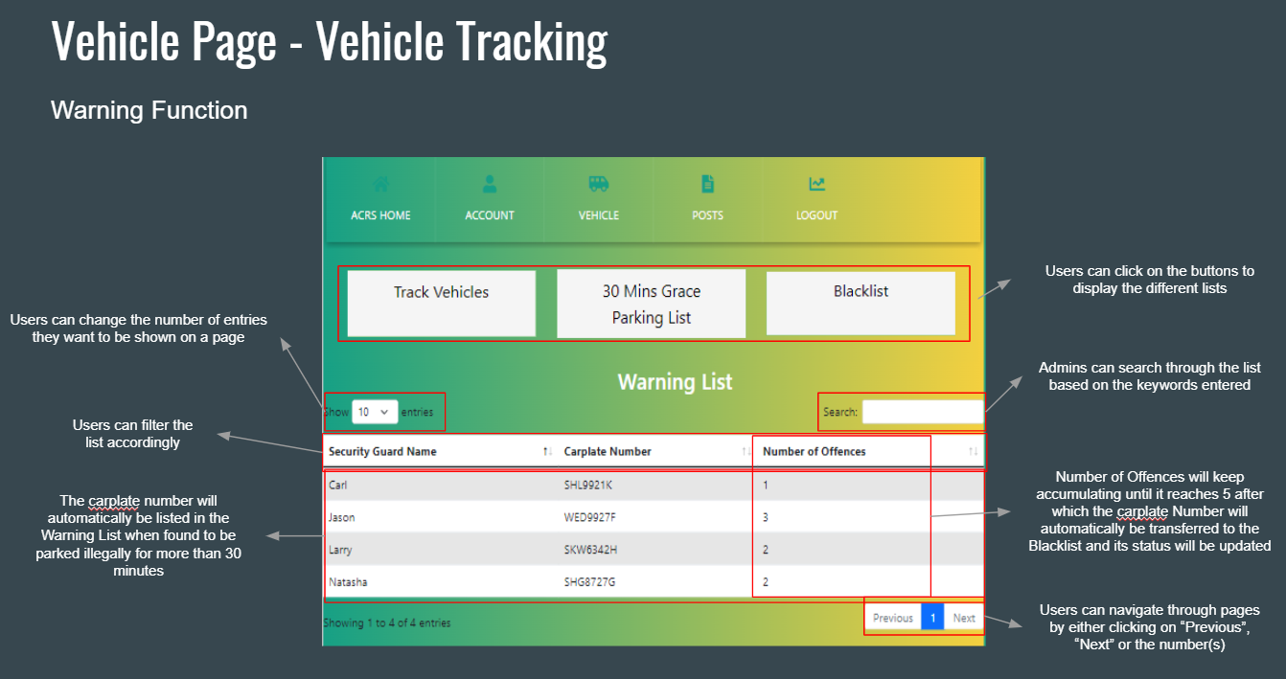

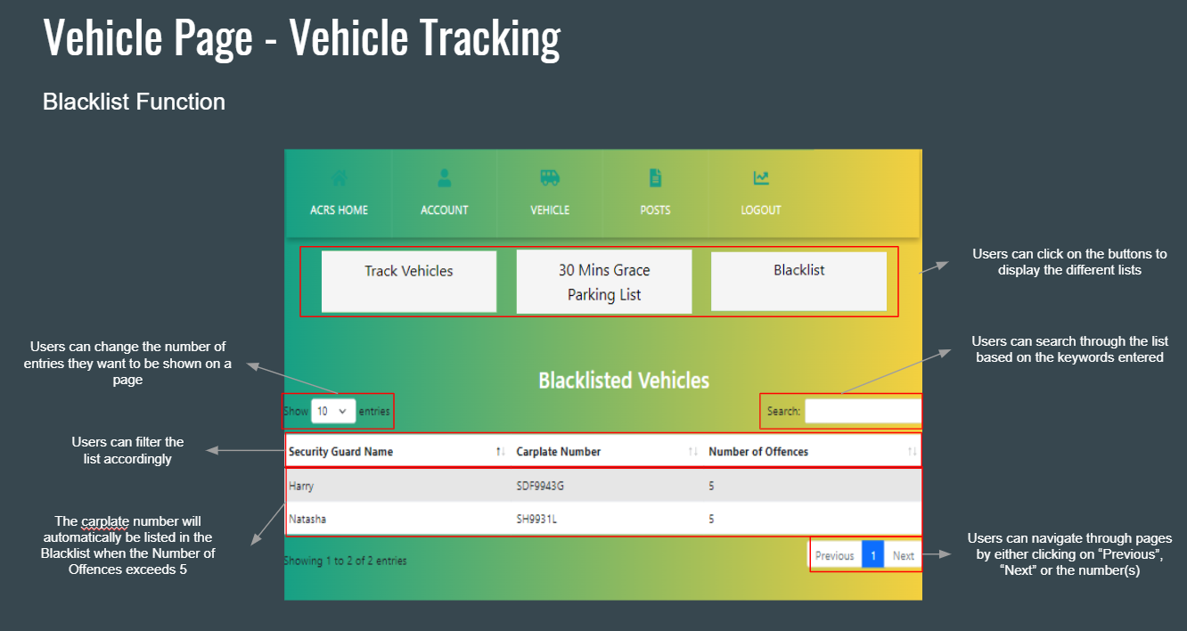

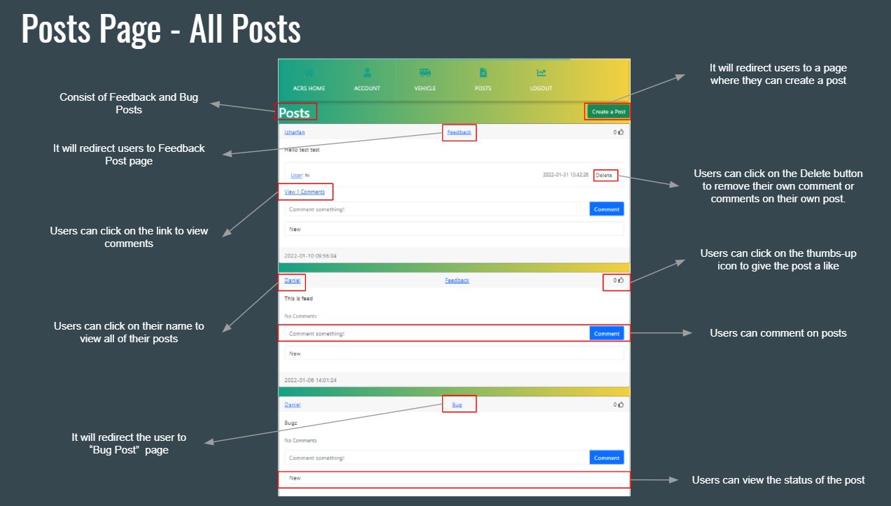

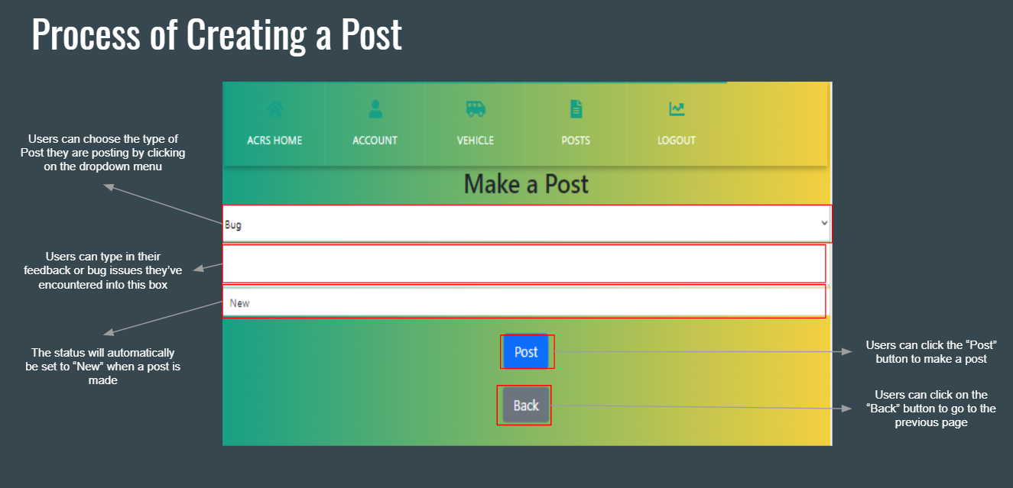

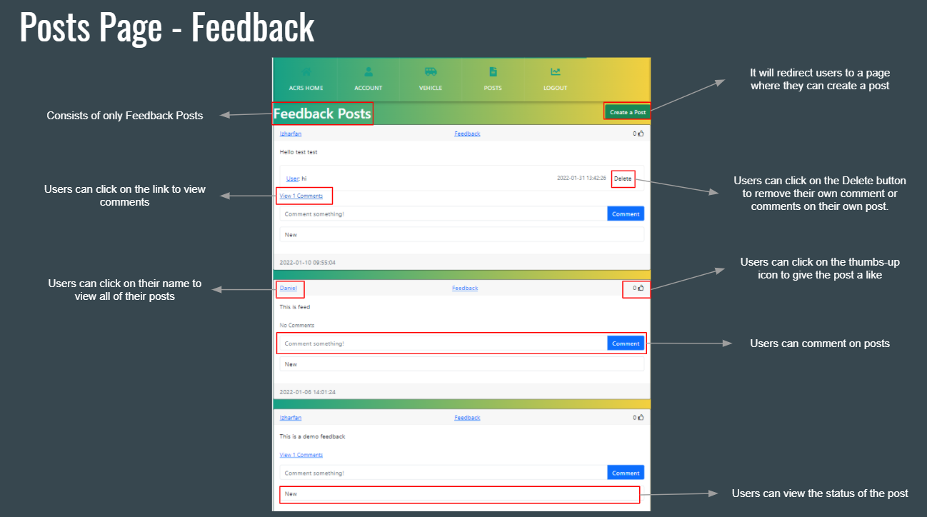

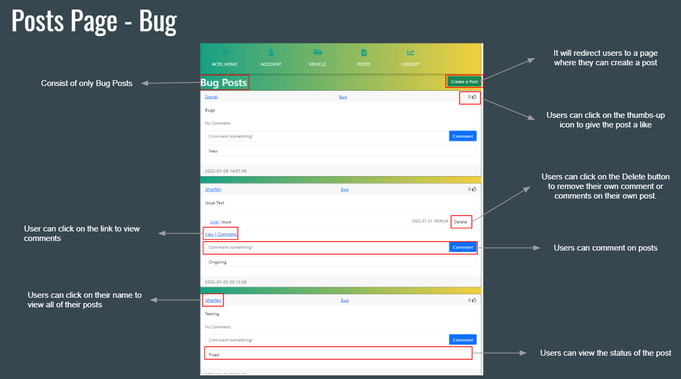

Admin (Estate Officer)

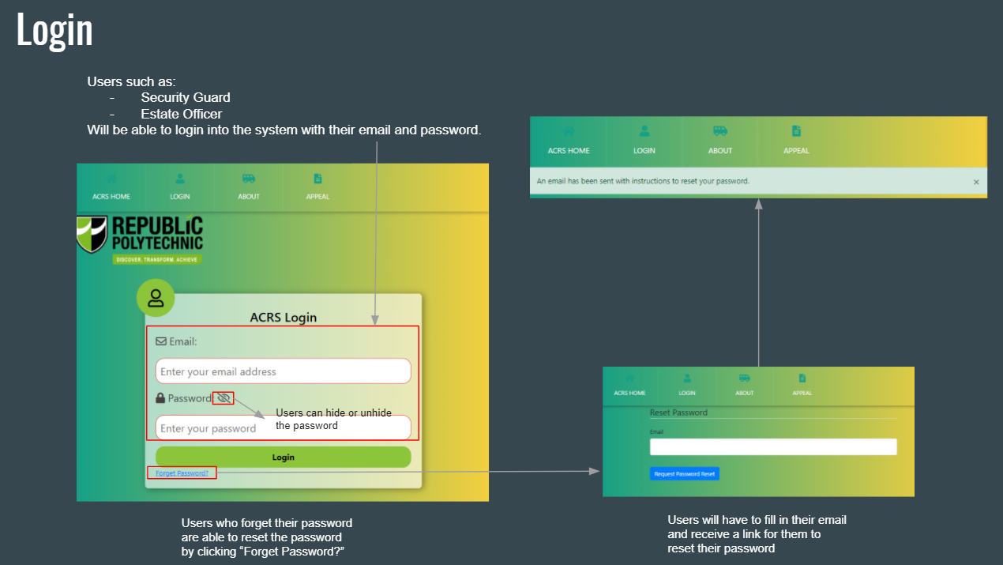

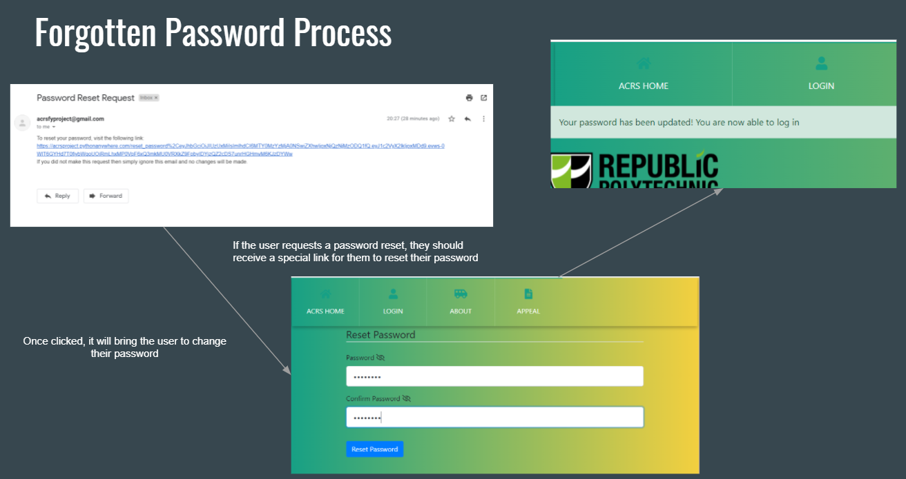

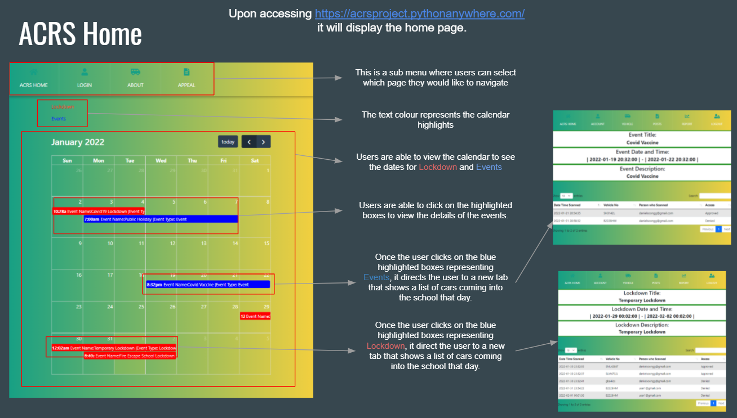

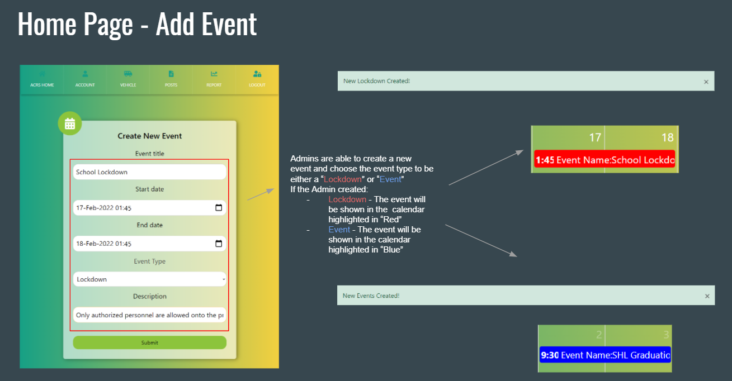

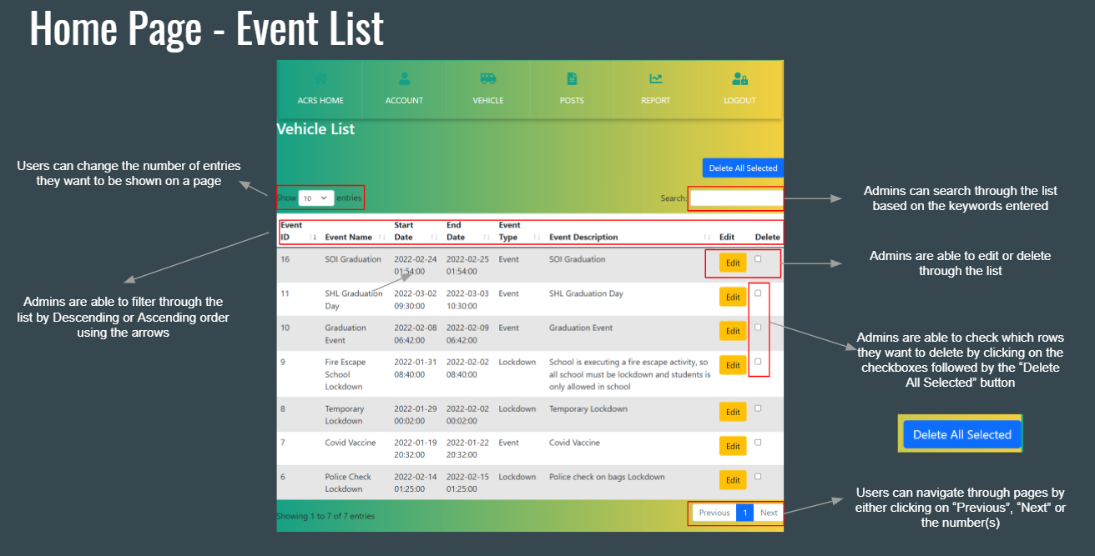

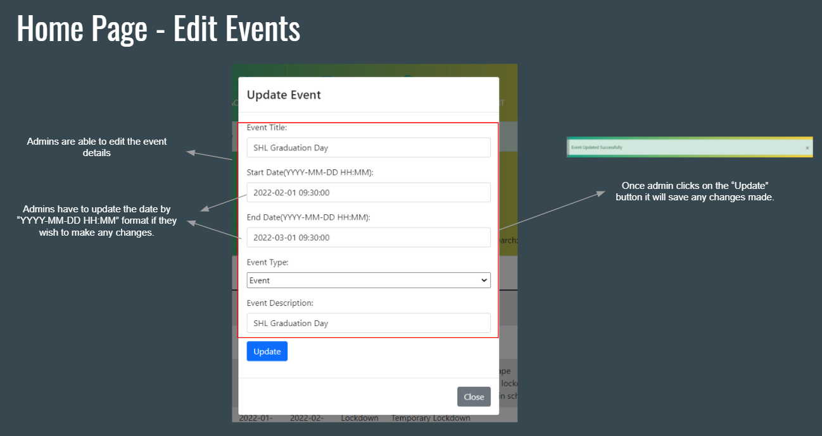

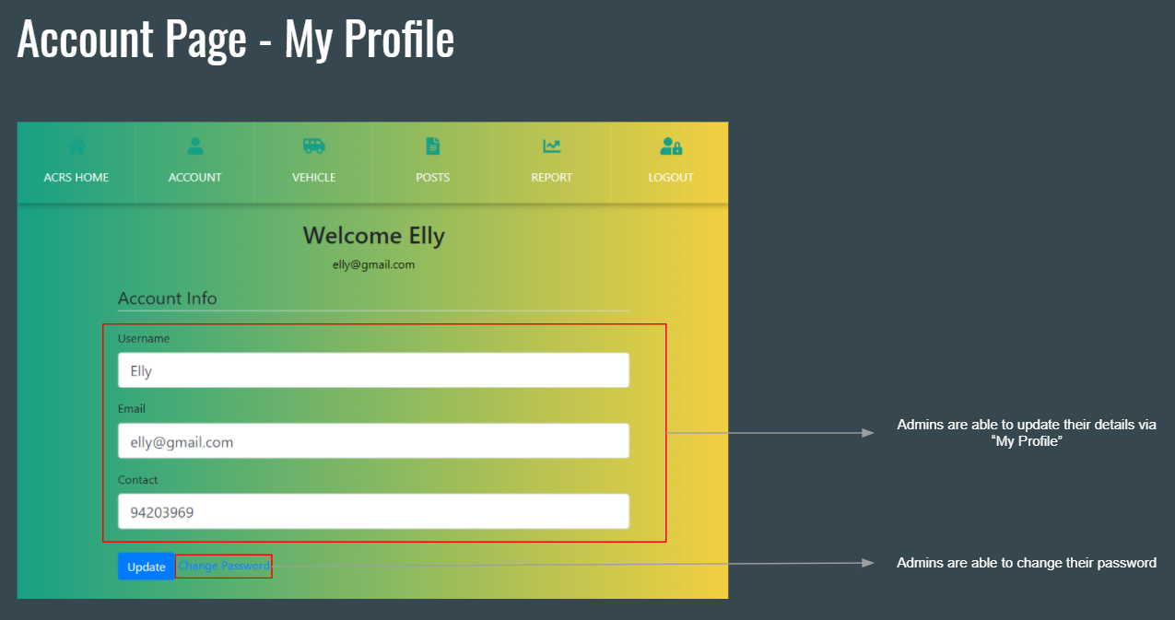

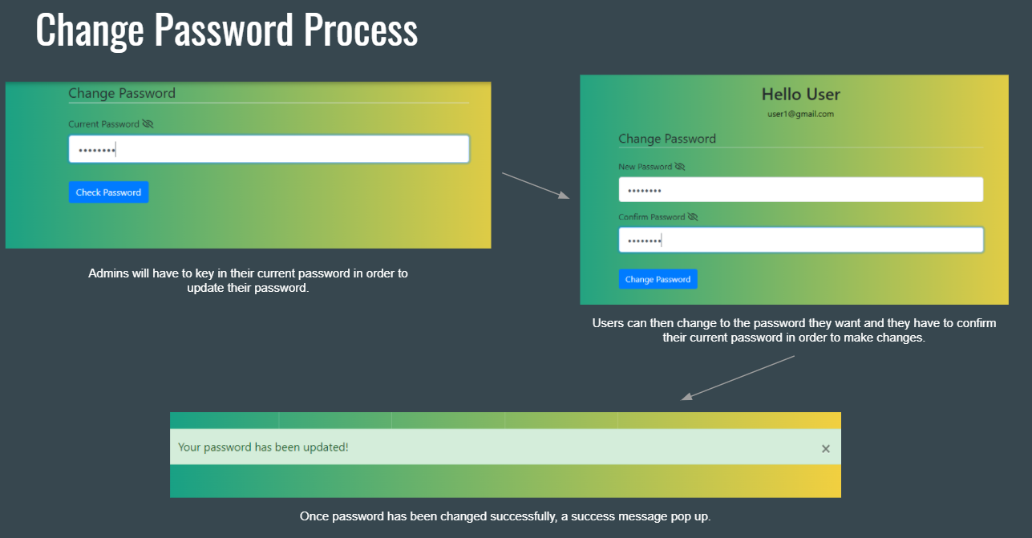

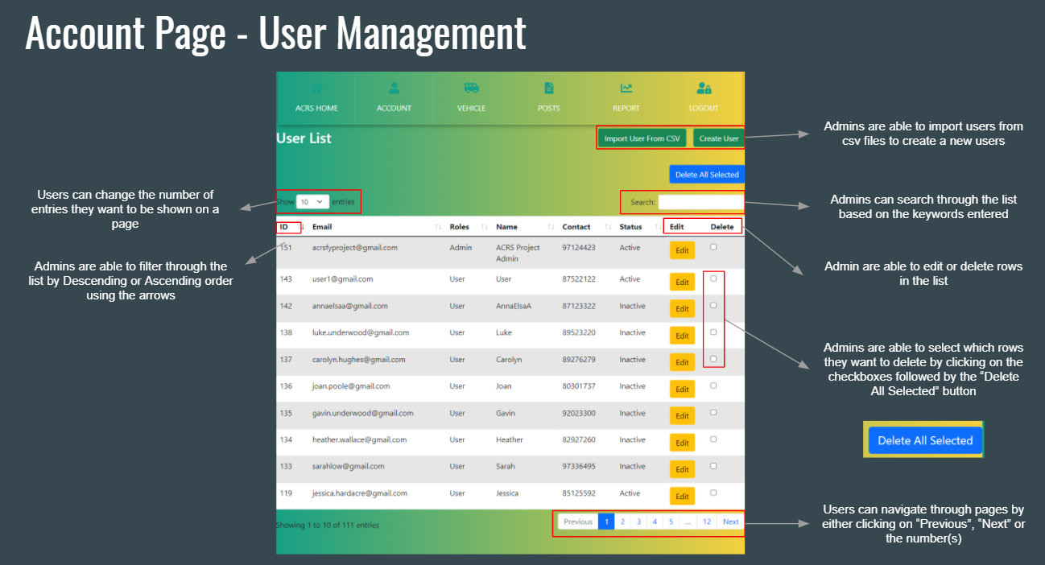

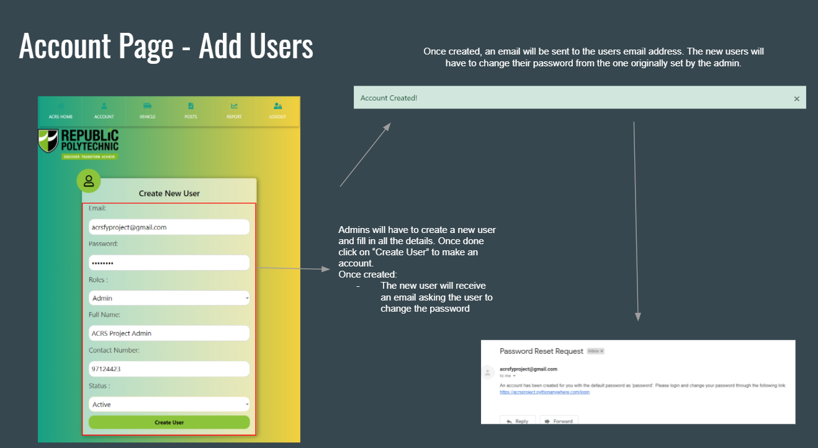

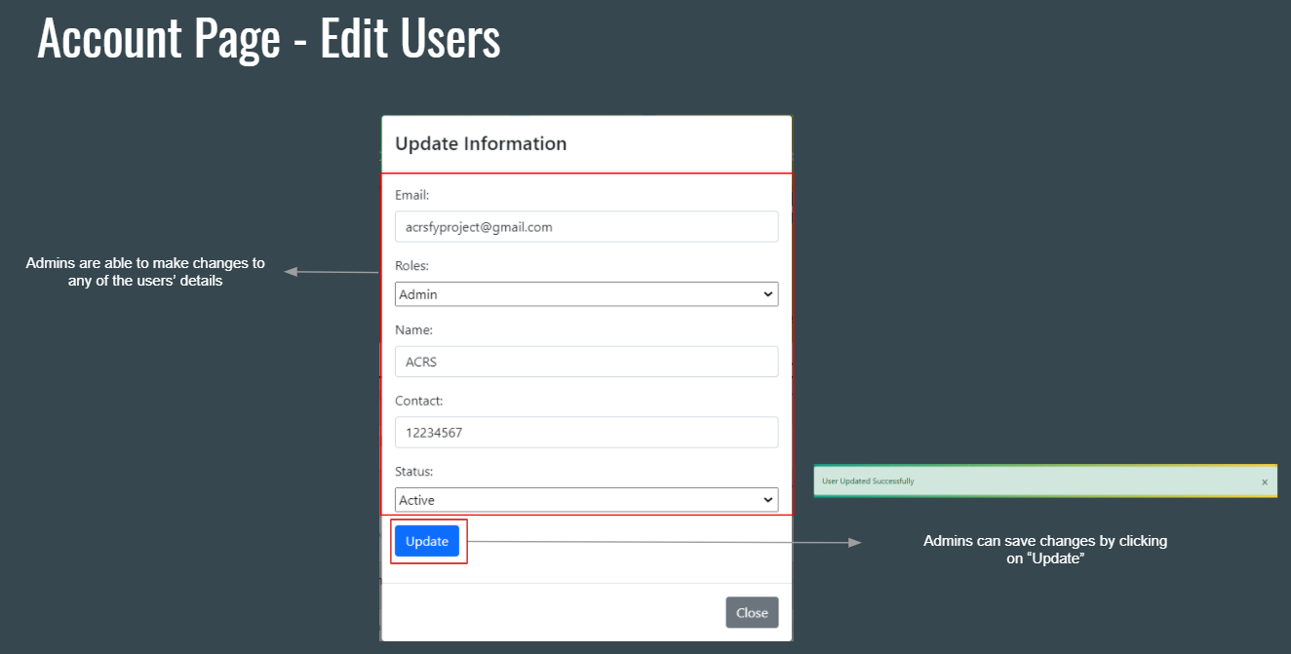

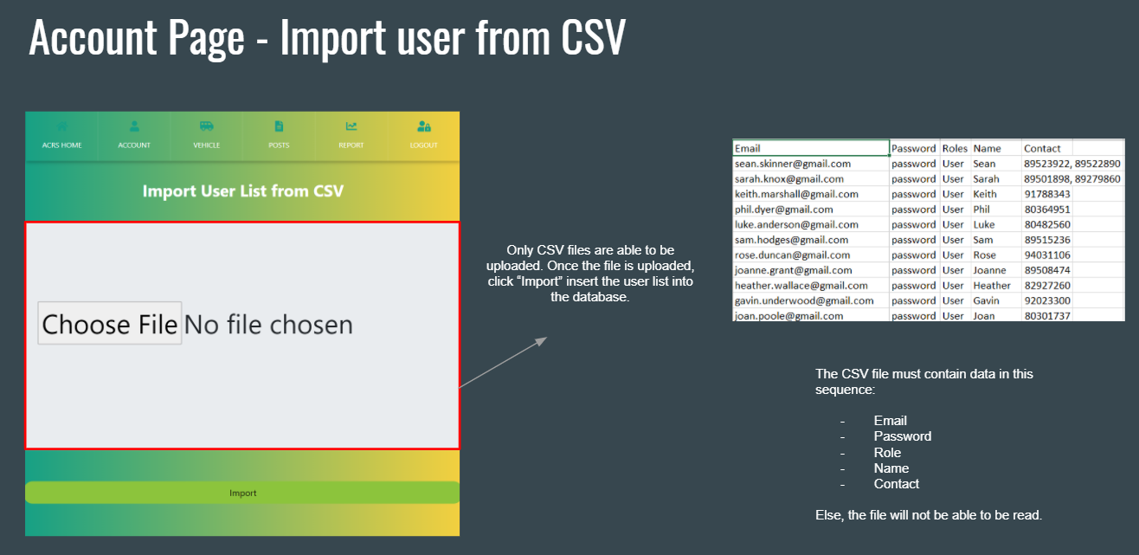

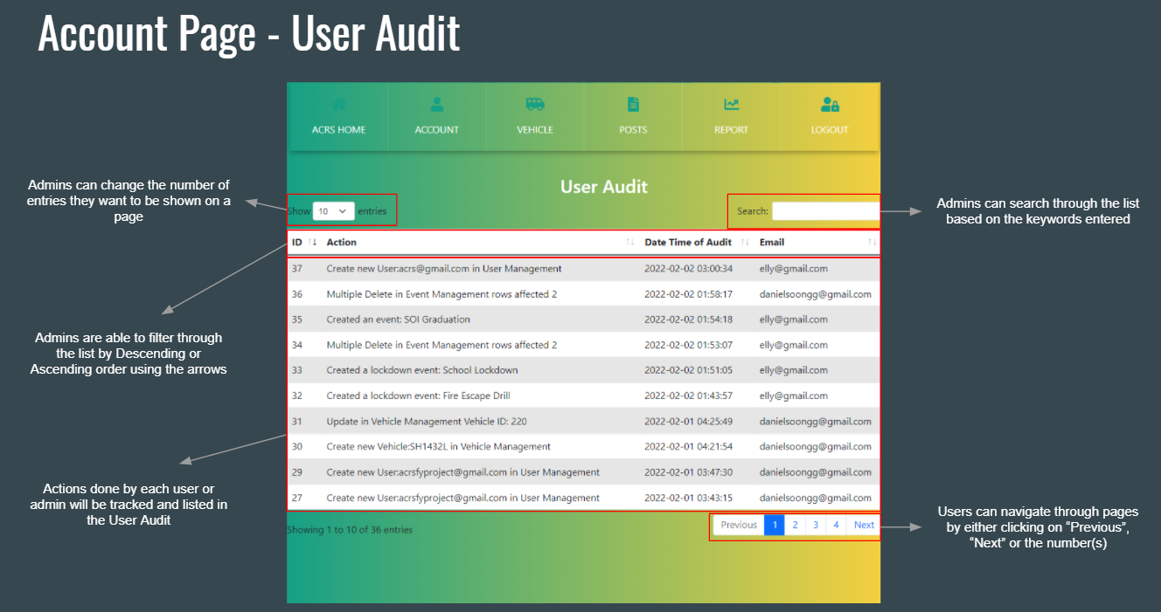

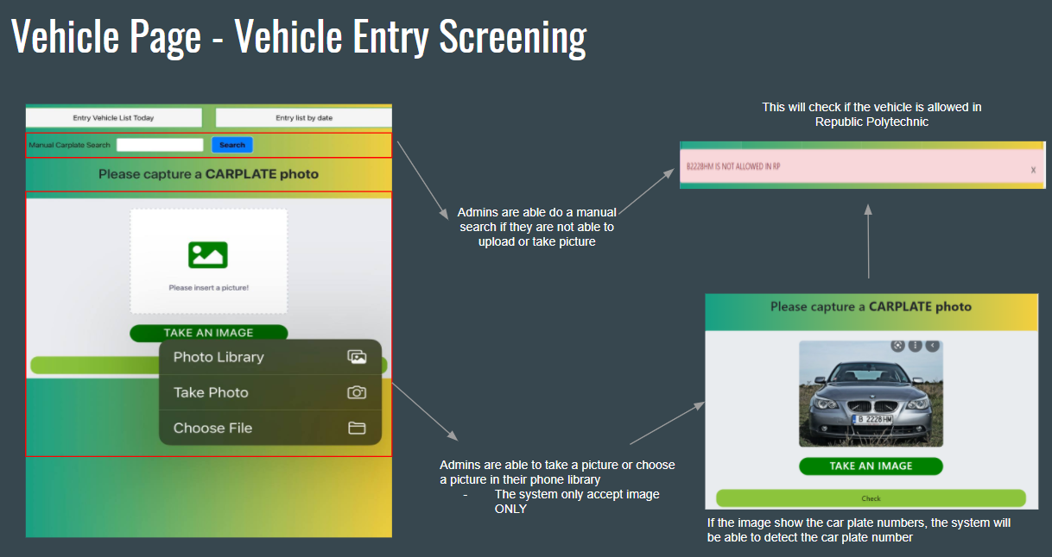

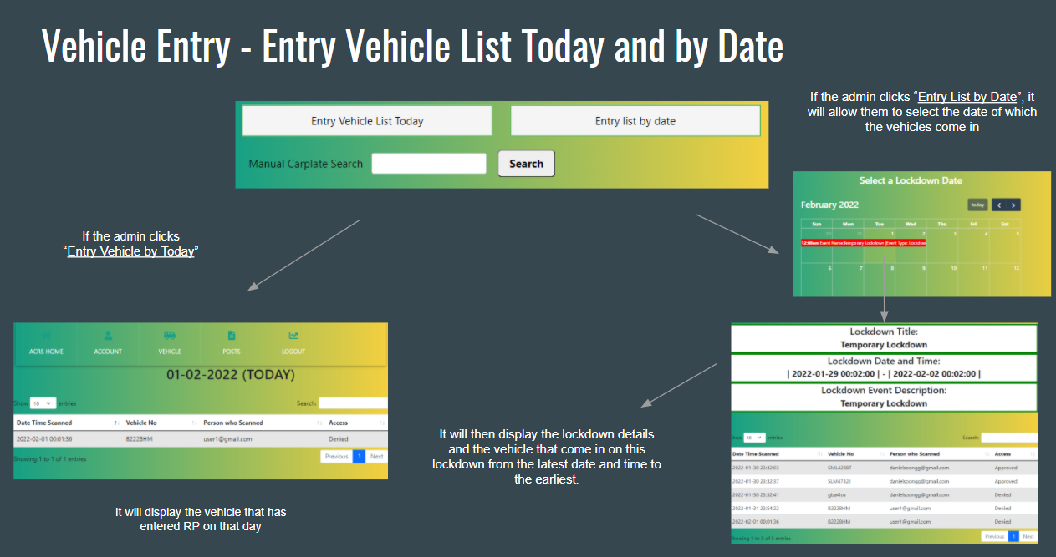

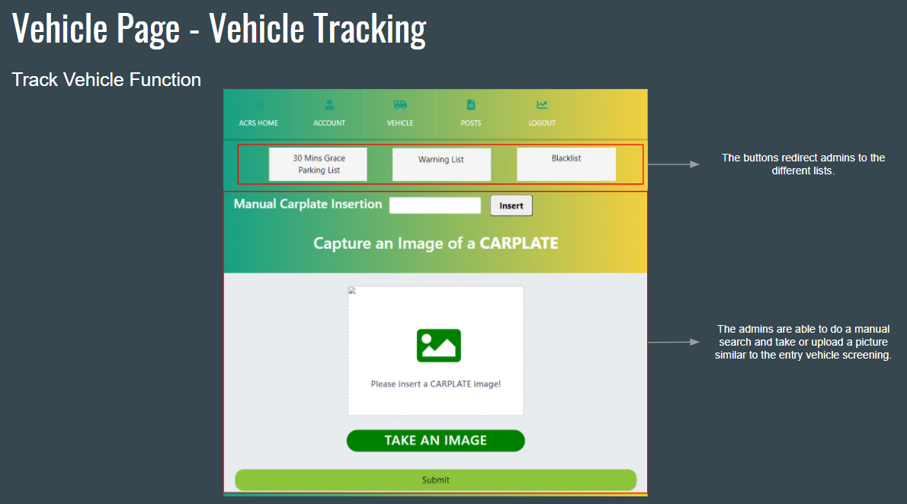

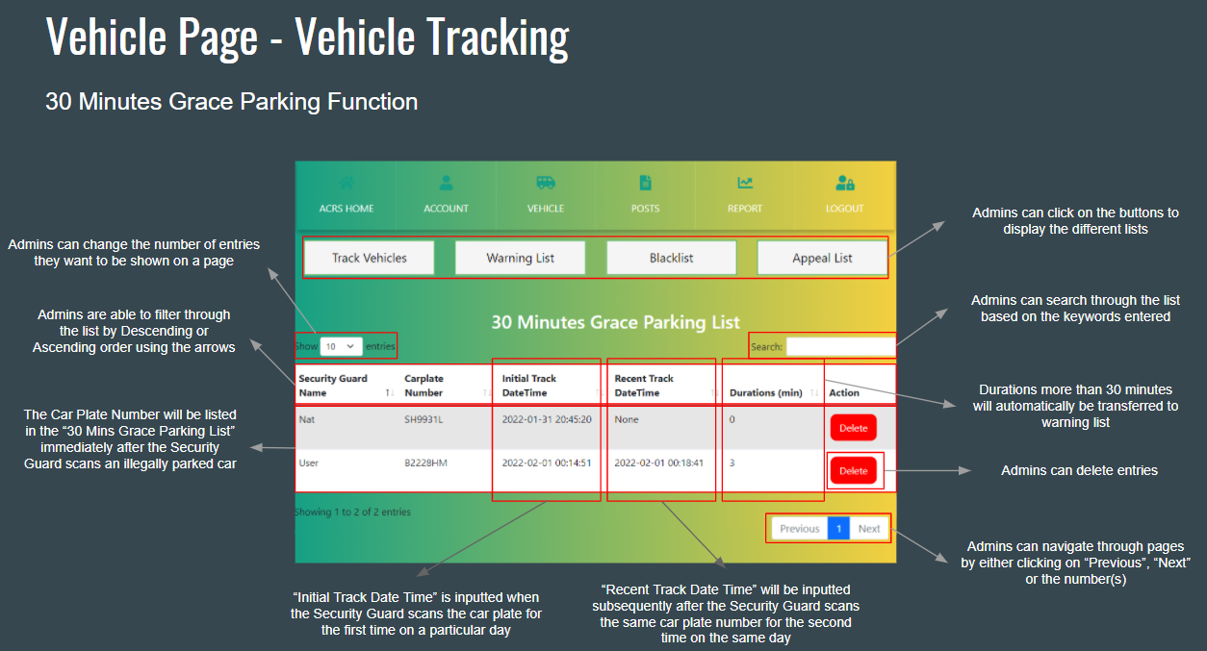

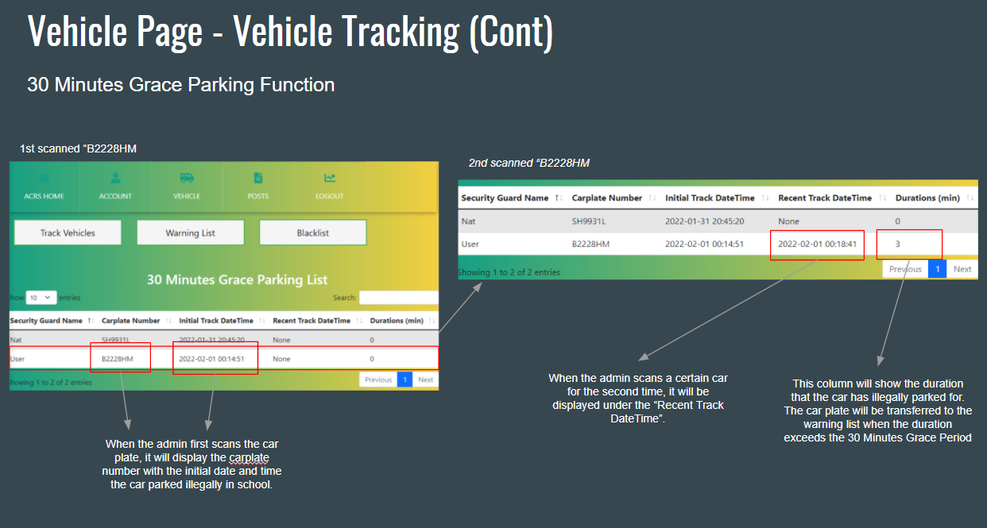

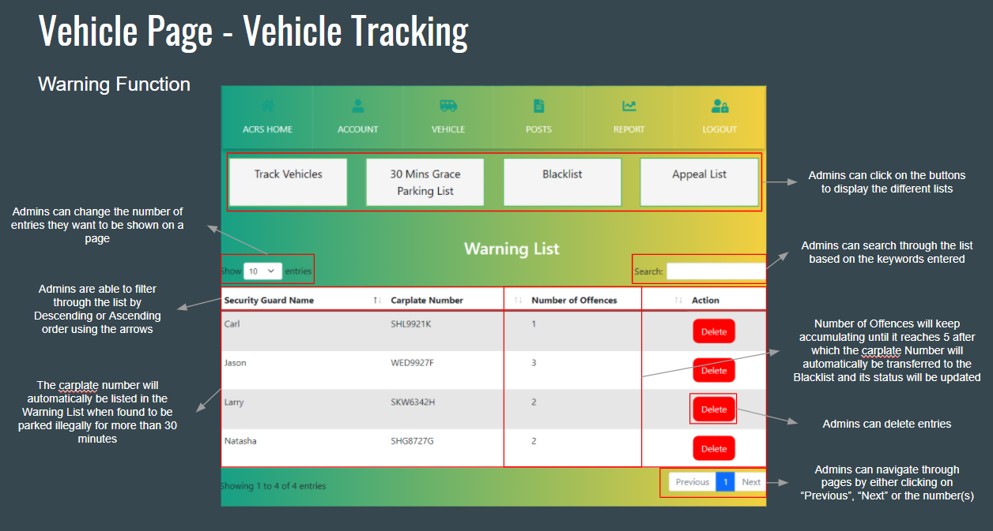

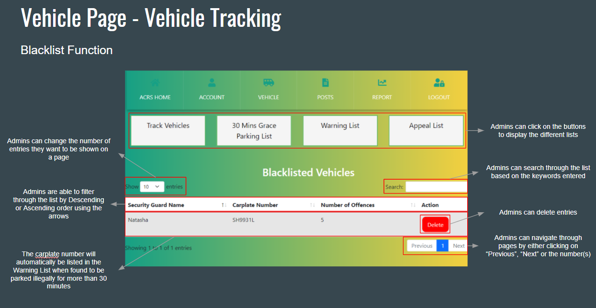

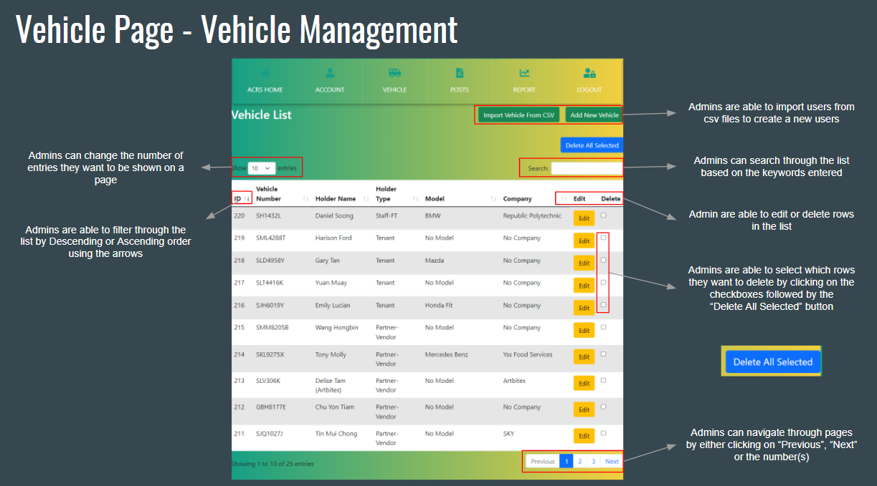

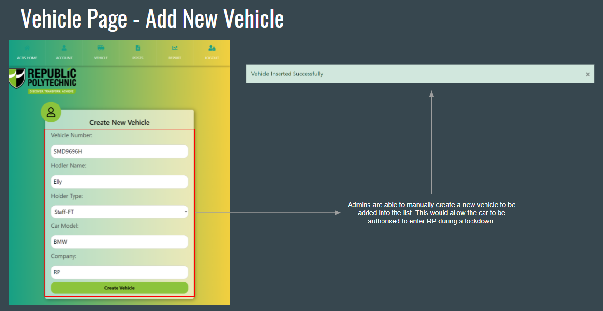

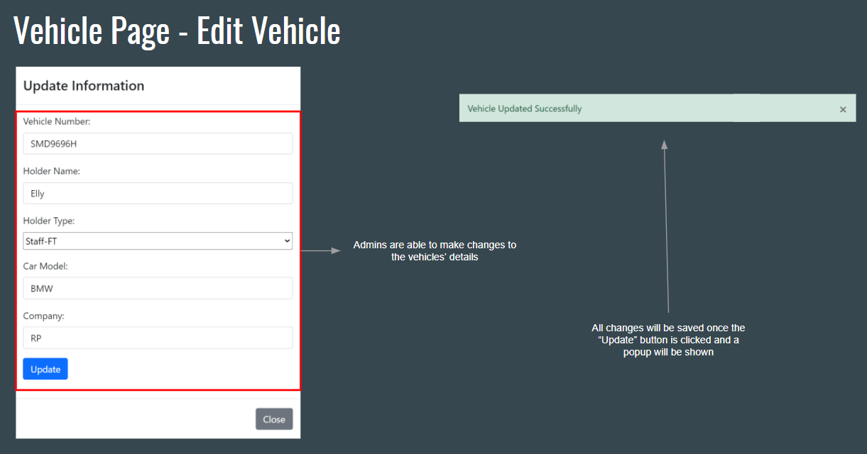

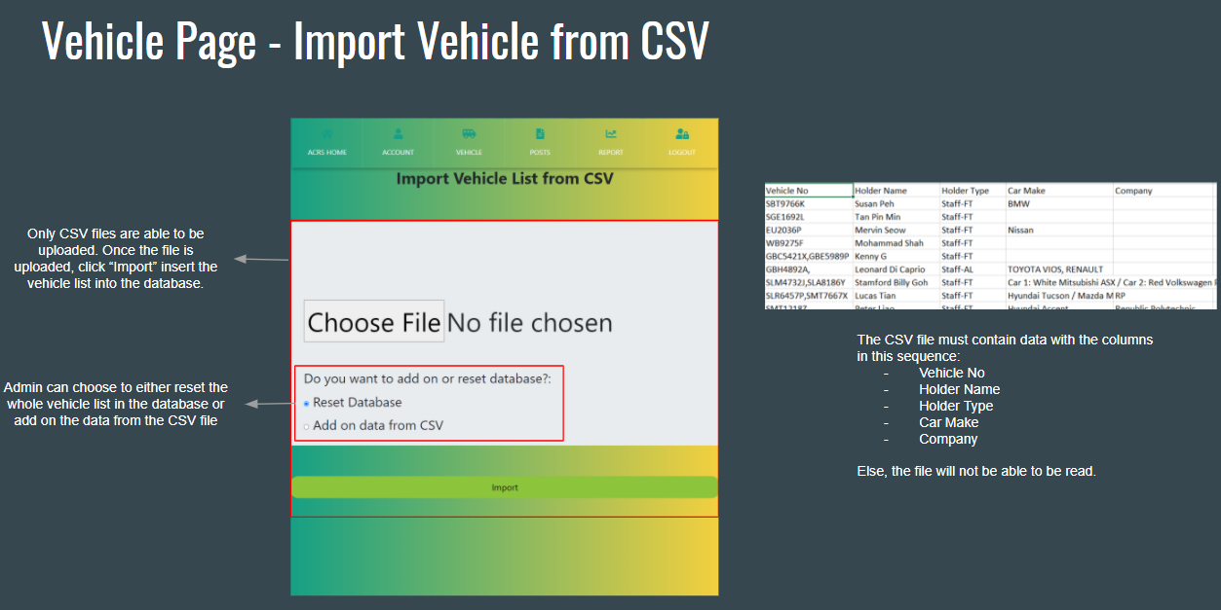

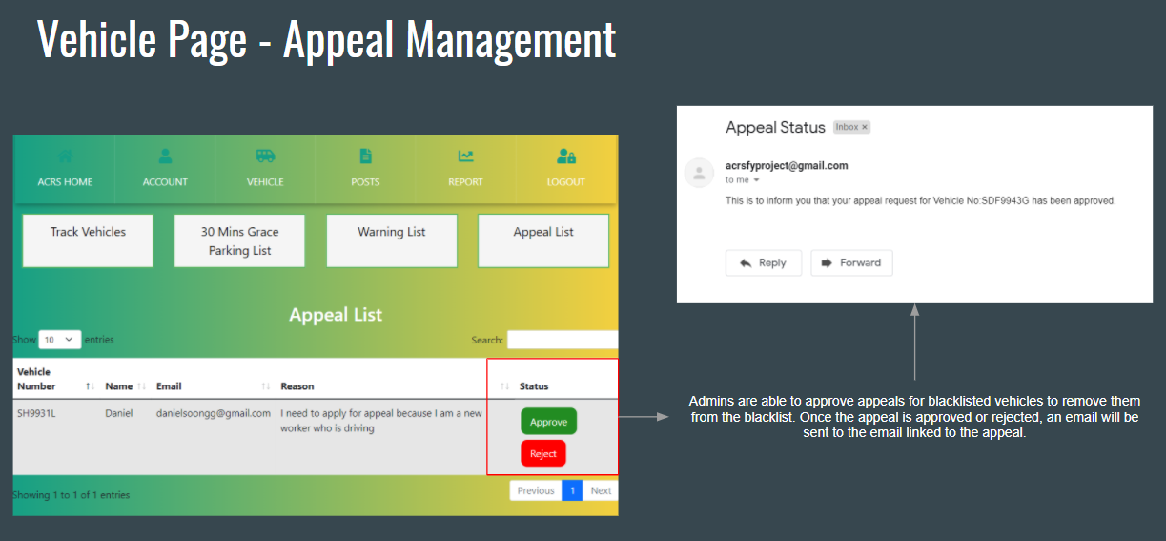

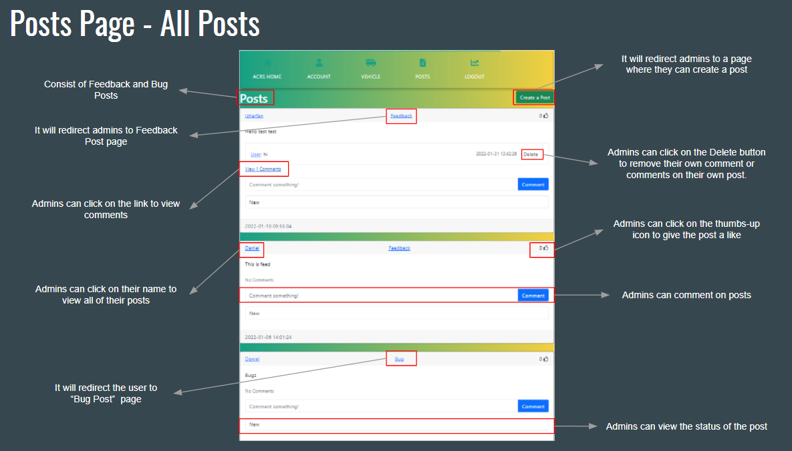

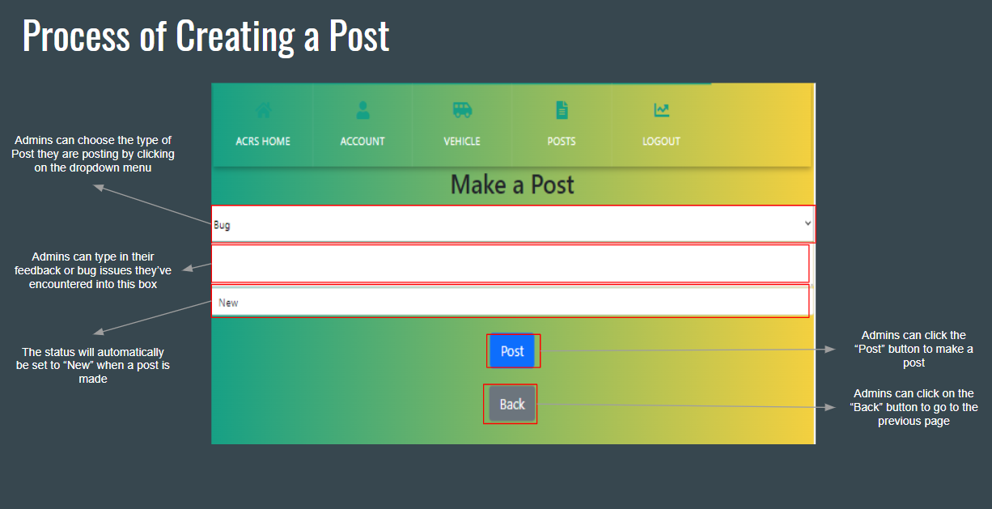

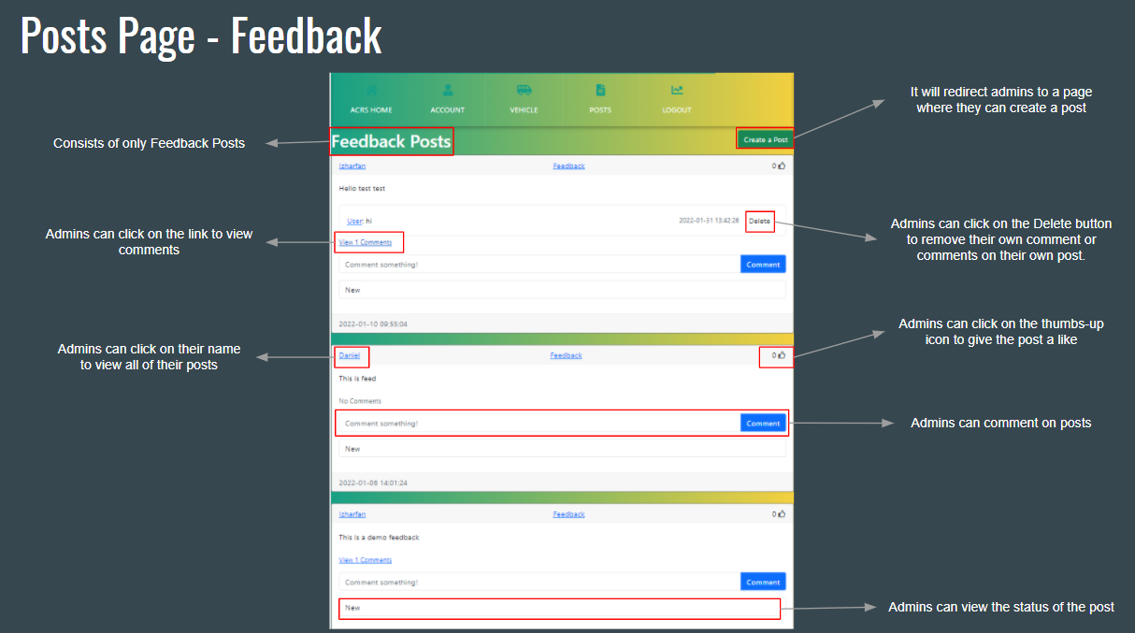

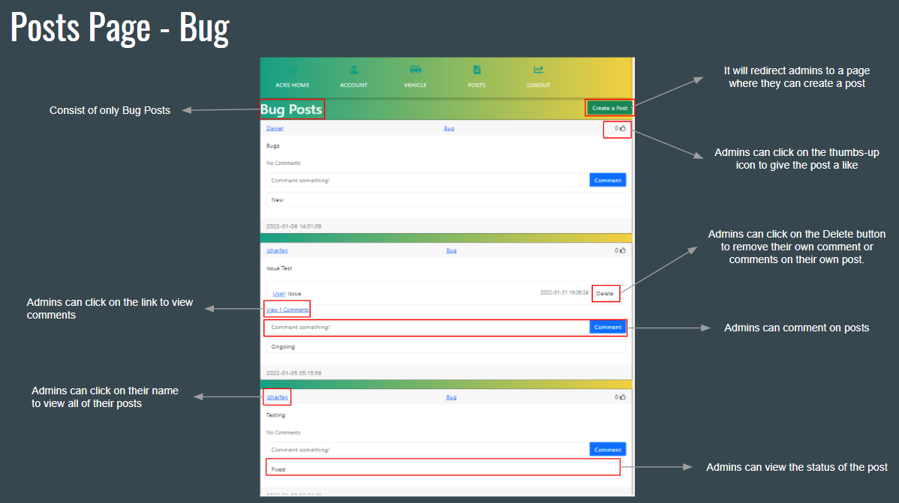

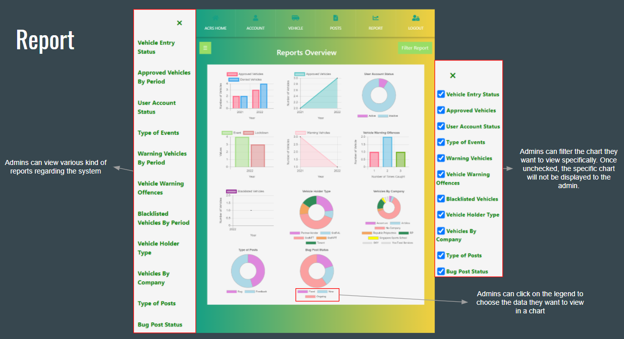

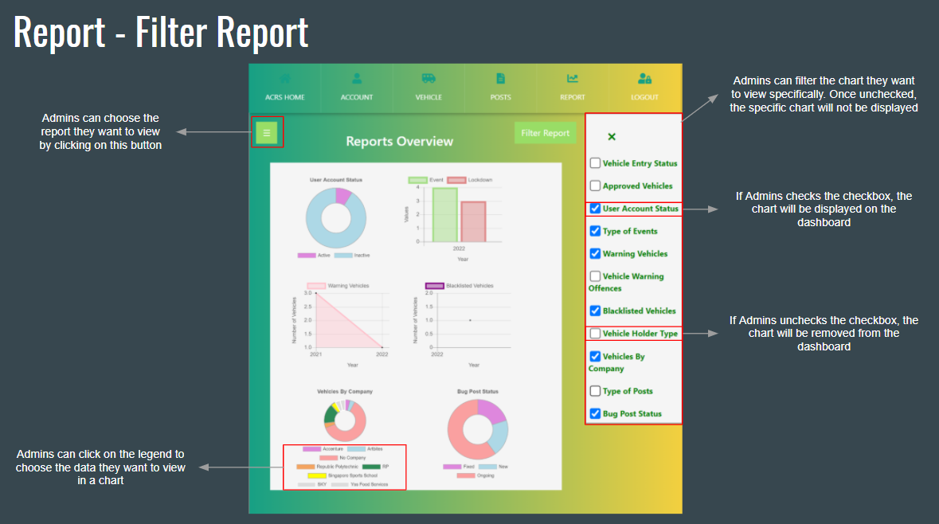

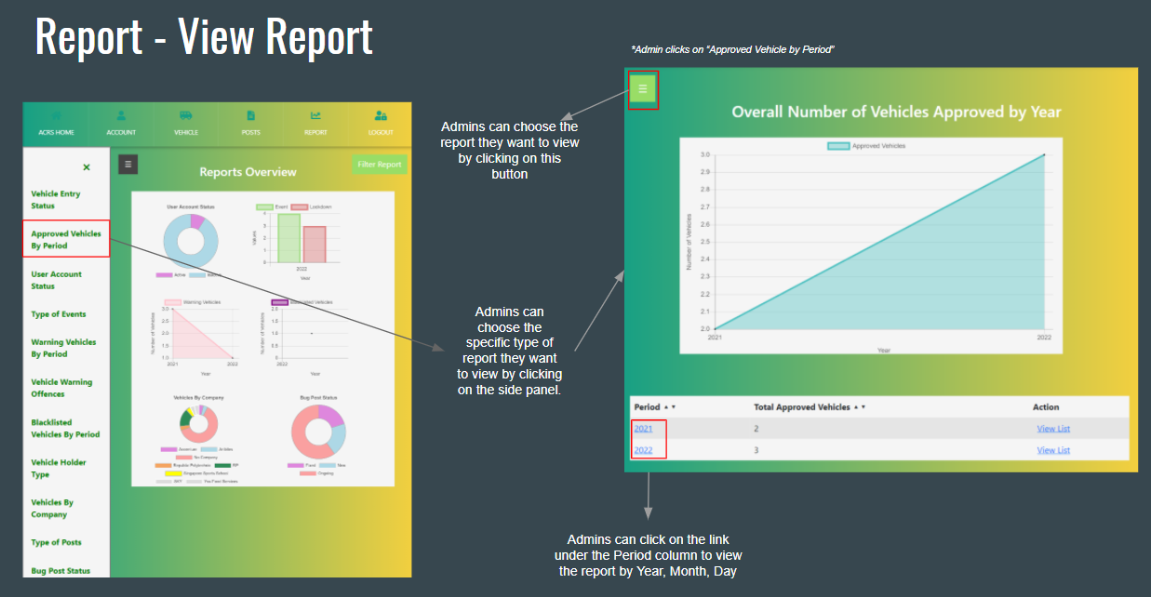

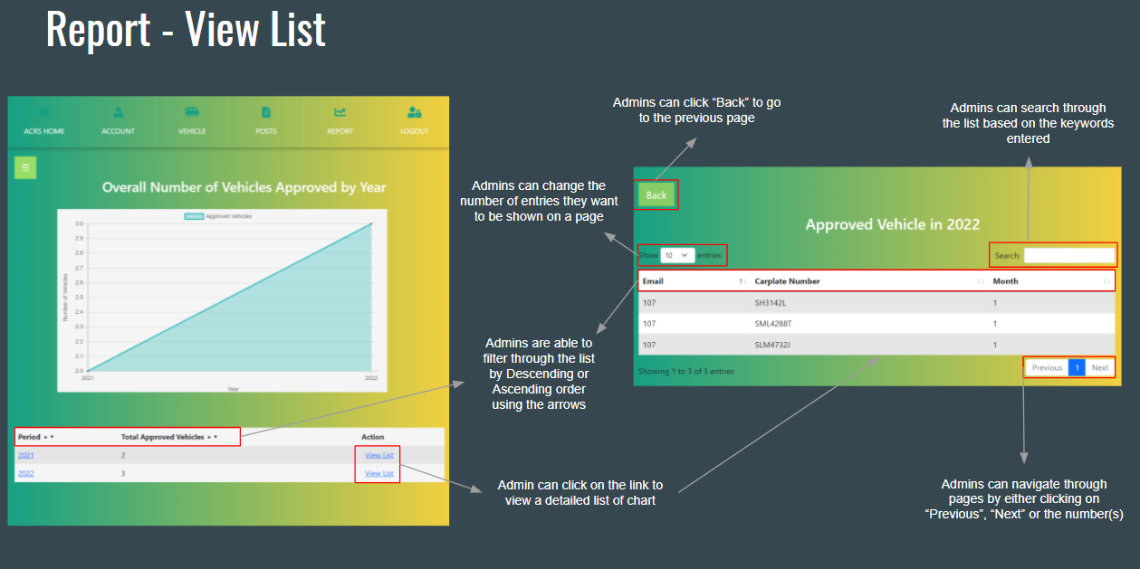

## Technical Documentation (Installation guide/Manual)

ACRS is a mobile friendly web application. Hence, no installation needed.

# Conclusions

Group:

**Accomplishments:**

* Successfully created a mobile friendly web application of ACRS
* Picked up a new programming language (Python Flask)

**Problems faced:**

* Frequently faced issues with the pythonanywhere servers

Daniel:

**Accomplishments:**

* Managed to implement the calendar function which allow user to view the events and make it clickable to view the details of the events
* Able to understand how to use SQLAlchemy fluently.
* Managed to learn how to implement AJAX table for most of the tables that are used in the system which allow me to understand how to customise how I want my AJAX table to be like such as (Disabling or Enabling certain features such as Filtering, Pagination, Search and control how many data we want to see in the system).
* Managed to learn how to implement an API into python which allows me to test if the API will be called when capturing a picture of a vehicle number.
* Able to understand how to calculate the date time by converting it into datetime format then change it to seconds and divide it by 60 in order to find out the duration of the dates.
* Managed to learn how to resize, compress images and rotate before capturing the car plate number so that all the images that will be uploaded from different mobile devices will automatically be set into its readable structure for API to understand.
* Able to implement a feature where users are able to key in the Vehicle number manually instead of capturing or uploading an image to check if the vehicle is approved in RP.
* Managed to learn how to import a CSV file by using libraries such as Pandas and converting it into an array class, which allowed me to check through the CSV format and append the clean data into the database.
* Able to guide and assist any code problems where teammates faced and assist them by helping to solve the errors.
* Successfully completed all the allocated task

**Problems faced:**

* When trying to start a project in the first few weeks, I have problems understanding Python Flask Framework and needed to get use to the way python flask is coded
* Encountered problems where plate recognizer API is not able to be called due to PythonAnywhere restraints which only allow premium members to use external APIs. So we will need to purchase the monthly subscription.
* After calling the API I have encountered problems such as when testing to capture the image of the car plate from mobile devices, it will not allow the images to be uploaded into the system due to the size of the image and how different mobile devices will rotate the images after capturing the image which make it not readable. Due to that, I have to learn how to automatically configure the images the user upload before calling the API to detect the vehicle number.
* Encountered problems doing the mass upload of the vehicle list where I have to learn how to use the pandas library, converting it into a list, creating a class and understanding how to check each data to prevent any “unclean” data to be inserted into the system.

Natasha:

**Accomplishments:**

* Successfully completed all allocated tasks
* Manage to implement User Mass Upload function in User Management for admin to import CSV file into the system
* Manage to implement AJAX Table for the 30 Minutes Grace Parking list which include filtering, searching and pagination
* Manage to implement manual insert function for user and admin to input the carplate number manually
* Manage to implement the calculation of duration between the initial datetime and recent datetime where if the duration is more than 30 minutes, the vehicle will be transferred to Warning List
* Manage to implement the Delete function for admin to remove the vehicle if the duration is calculated to be less than 30 minutes
* Manage to implement a list of data in a table with filter function for each report
* Manage to implement AJAX Table for the View List function where it shows a detailed list of the report which include filtering, searching and pagination
* Manage to implement 11 reports based on the application
* Manage to implement chart for each of the reports
* Manage to implement a clickable legend where user can click on the legend to choose the data they want to view in the chart
* Manage to implement a Dashboard with all the charts showing
* Manage to implement a Sidebar for the list of report
* Manage to implement checkbox for user to filter the charts they want to view on the dashboard

**Problems faced:**

* Faced difficulties when implementing the User Mass Upload from CSV file into the system as there are multiple conditions required to be checked for the CSV file to be successfully imported
* Faced some difficulties when implementing the manual insert function
* Faced difficulties implementing the checking of duration as calculation is involved and the time format were required to change to Singapore so that when the duration is more than 30 minutes, the carplate should automatically transfer to the warning list
* Faced difficulties implementing the charts for each reports as I was unfamiliar with Chart,js since it was never taught before
* Faced some difficulties when implementing the dashboard to showcase all the charts
* Faced some issues when implementing the filter chart function where admin can checked the checkbox of the report they want to view

Izharfan:

**Accomplishments:**

* Successfully completed all allocated tasks
* Manage to update user details for My Profile and User Management
* Manage to implement Change Password in My Profile
* Manage to display data from database of users in a table for User Management
* Manage to implement usage of AJAX data table in User Management with searching, pagination and filter functions
* Manage to create and implement multiple delete function using checkbox
* Manage to implement a Posts system where users can post feedbacks and bugs, and like and comment on the posts
* Manage to implement sending email to users for forget password and when admin creates a new user

**Problems faced:**

* Faced some difficulties in checking user’s password for Change Password in My Profile
* Faced some issues regarding foreign keys while implementing update functions for My Profile and User Management
* Faced issues and difficulties implementing multiple delete function using checkbox such as unable to delete more than one user at a time.
* Faced issues implementing the Posts system such as unable to like and see comments.
* Faced issues implementing send email feature.

Elly:

**Accomplishments:**

* Successfully completed allocated tasks
* Able to retrieve vehicle information from database
* Able to display vehicle information in table format
* Able to edit and update vehicle information
* Manage to implement usage of AJAX data table in
  + Vehicle Management,
  + Warning List,
  + Blacklist and
  + Appeal List

with searching, pagination and filter functions

* Manage to implement multiple delete function using checkbox
* Manage to implement Warning Function
* Manage to display vehicles with Warning and Blacklist status
* Able to implement an appeal function for public users to submit appeals
* Able to implement appeal management
* Able to approve and reject appeals
* Able to view all appeals
* Manage to implement email trigger when an appeal is rejected or approved

**Problems faced:**

* Difficulty in implementing email trigger
* Difficulty in implementing Warning Function
* Faced some issues with approving and rejecting appeal
* Issue with retrieving data from database

# References

* Flask Essential Training Video Tutorial (LinkedIn)
  + <https://www.linkedin.com/learning/flask-essential-training/next-steps?autoAdvance=true&autoSkip=true&autoplay=true&resume=false&u=41614228>
* Python Website Full Tutorial - Flask, Authentication, Databases & More
  + <https://www.youtube.com/watch?v=dam0GPOAvVI>
* Ajax Table
  + <https://www.youtube.com/watch?v=IsuhCAptNbg>
  + <https://github.com/miguelgrinberg/flask-tables>
* SQLAlchemy Database
  + <https://www.youtube.com/watch?v=uZnp21fu8TQ>
  + <https://www.youtube.com/watch?v=Tu4vRU4lt6k>
  + <https://stackoverflow.com/questions/27158573/how-to-delete-a-record-by-id-in-flask-sqlalchemy>
  + <https://stackoverflow.com/questions/36571706/python-sqlalchemy-filter-by-datediff-of-months>
  + <https://stackoverflow.com/questions/4926757/sqlalchemy-query-where-a-column-contains-a-substring>
  + <https://stackoverflow.com/questions/60515826/sqlalchemy-difference-between-two-dates>
  + <https://pretagteam.com/question/sqlalchemy-get-every-row-the-matches-query-and-loop-through-them>
  + <https://www.codegrepper.com/code-examples/python/sqlalchemy+filter+between+dates>
  + <https://www.codegrepper.com/code-examples/assembly/sqlalchemy+filter+by+date>
* CRUD (Adding, Deleting & Updating)
  + <https://www.youtube.com/watch?v=1nxzOrLWiic>
  + <https://www.youtube.com/watch?v=AzjPMAz9JQU>
* API for Automatic Plate Recognizer
  + <https://docs.platerecognizer.com/#read-number-plates-from-an-image>
* PythonAnywhere Account and create MySQL database
  + <https://www.youtube.com/watch?v=MPXGSkzUtn4>
* User Account and Profile
  + <https://youtu.be/803Ei2Sq-Zs>
* Posts
  + <https://youtu.be/GQcM8wdduLI>
  + <https://youtu.be/f_bml-MILAs>
  + <https://youtu.be/M_OKJnIdYeU>
* Email and Password Reset
  + <https://youtu.be/vutyTx7IaAI>
* Reports
  + <https://towardsdatascience.com/flask-and-chart-js-tutorial-i-d33e05fba845>
  + <https://www.chartjs.org/docs/latest/charts/doughnut.html>
  + <https://www.youtube.com/watch?v=024yLQ1K1Ws>
  + <https://www.chartjs.org/docs/latest/charts/bar.html>
  + <https://www.chartjs.org/docs/3.4.0/configuration/interactions.html>
* JSON
  + <https://www.geeksforgeeks.org/response-json-python-requests/>
  + <https://stackoverflow.com/questions/56037043/how-to-show-specific-data-from-json-array-using-c-sharp>
  + <https://stackoverflow.com/questions/34010569/indexerror-list-index-out-of-range-python-json>
  + <https://stackoverflow.com/questions/14740633/how-to-get-data-from-json-array-by-python>
* Delay
  + <https://www.guru99.com/python-time-sleep-delay.html>
* HTML Styles
  + <https://www.w3schools.com/html/html_styles.asp>
  + <https://stackoverflow.com/questions/5813344/how-to-customize-input-type-file>
  + <https://www.youtube.com/watch?v=0HCiH4Tk04I>
  + <https://www.youtube.com/watch?v=AYjOyQhZiK0>
* Compress file size
  + <https://www.geeksforgeeks.org/validation-of-file-size-while-uploading-using-javascript-jquery/>
  + <https://stackoverflow.com/questions/48089942/compress-and-upload-image-using-python-flask>
  + <https://sempioneer.com/python-for-seo/how-to-compress-images-in-python/>
  + <https://www.geeksforgeeks.org/python-pil-image-resize-method/>
  + <https://auth0.com/blog/image-processing-in-python-with-pillow/>
  + <https://stackoverflow.com/questions/4228530/pil-thumbnail-is-rotating-my-image>
* Modal Box
  + <https://www.w3schools.com/howto/howto_css_modals.asp>
* Python Basics
  + <https://careerkarma.com/blog/python-uppercase/>
  + <https://www.w3schools.com/python/ref_string_split.asp>
  + <https://www.geeksforgeeks.org/how-to-create-a-list-of-object-in-python-class/>
  + <https://www.journaldev.com/23763/python-remove-spaces-from-string>
  + <https://www.geeksforgeeks.org/python-remove-list-elements-containing-given-string-character/>
  + <https://stackoverflow.com/questions/31997859/bulk-insert-a-pandas-dataframe-using-sqlalchemy/33529549>
  + <https://stackoverflow.com/questions/18708050/bulk-insert-list-values-with-sqlalchemy-core>
  + <https://www.kite.com/python/answers/how-to-remove-empty-strings-from-a-list-of-strings-in-python>
* Pandas Excel
  + <https://www.youtube.com/watch?v=x576UAaPv8Y>
  + <https://datatofish.com/import-csv-sql-server-python/>
  + <https://stackoverflow.com/questions/58010594/pandas-ordereddict-strip-space-read-excel>
  + <https://stackoverflow.com/questions/29314033/drop-rows-containing-empty-cells-from-a-pandas-dataframe>
  + <https://www.datacamp.com/community/tutorials/for-loops-in-python>
  + <https://www.datacamp.com/community/blog/python-pandas-cheat-sheet?utm_source=adwords_ppc&utm_medium=cpc&utm_campaignid=12492439676&utm_adgroupid=122563405321&utm_device=c&utm_keyword=extract%20columns%20pandas&utm_matchtype=b&utm_network=g&utm_adpostion=&utm_creative=504158801728&utm_targetid=aud-392016246653:kwd-614516587576&utm_loc_interest_ms=&utm_loc_physical_ms=9062518&gclid=CjwKCAiAh_GNBhAHEiwAjOh3ZPys0FY5vSiCND9g50H5xz_y71eyX5W5TUE7jjH5sFPFxzS2dIosnhoCMykQAvD_BwE>
  + <https://www.youtube.com/watch?v=XWI1m5AWeaw>
  + <https://medium.com/@chaimgluck1/working-with-pandas-fixing-messy-column-names-42a54a6659cd>

# Appendices

Appendix A:

GitHub Source Code : <https://github.com/shannenang/2021S2FYP-Daniel>

Appendix B:

PythonAnywhere ACRS Web: <https://acrsproject.pythonanywhere.com/>

# Project Poster

**